Burkhard Heim’s FTL Drive and the UFO Conspiracies
by Michael Joseph McCarron

- history of UFOs
- US Govt UAP studies
- Steve Greer Disclosure Project
- Luis Elizondo
- Real Science: Burkhard Heim, etc.
- Gravitational Wave Propulsion (Baker, Fontana, Pais, Chiao papers)
- LENR, and 'Free Energy'

UFO/UAP Observed Capabilities:
How is it that people have witnessed objects in the sky that defy the latest aerospace technology? These encounters are not new to human civilization, the famous rocket scientist, Hermann Oberth, one of the founders of rocketry, in a lecture on UFO sightings relays the following:

“For centuries people have seen strange, shining objects in the Sky. The oldest reports are found from Plinius and Seneca, according to the Basler National Newspaper, and have been named 'Shining Shields.'

There are about 50 observations knnown from the time before World War II. Then the number of appearances increased; the Allies thought it was a German secret weapon, and the Germans thought it was one of the Allies. Since, 1947, the reports of eyewitnesses increased considerably. It is said by the English Air Marshall Lord Dowding that there have been 10,000 (reports) by 1953.

The appearances are usually described as disks, sometimes as balls or ellipsoids. It sometimes happens that these disks placed one upon the other, the largest in the center, the smaller toward the ends, to form an object the shape of a cigar, which then flies away with high speed.

Sometimes one already saw such a cigar (UFO) stopping and untie into seperate disks, the disks always fly in a manner as if thee drive is acting perpendicular to the plane of the disk [z-coordinate]; when they are suspended over a certain terrain they keep horizontal; when they want to fly very quick, the tilt (tip) and fly with the plane directed forward. In sunlight, which is brighter then their own gleaming, they appear glittering like metal. They are dark orange and cherry red at night, if there is not much power necessary for the particular movement, for instance, when they are suspended calm. Then, they also do not shine very much. IF more driving power is necessary, the shining increases (brightens) and they appear yellow, yellow-green like copper flame, and in a state of highest speed or acceleration extremely white.”

“But if one does not consider the type and development of gravity fields, the assumption of artificial gravity fields would explain all the reports completely” “The shining could result form the change of the 'Hemmstrahlen' (drive waves) into longer waves of light and electricity.”
(Herman Oberth, Lecture Notes on UFO Properties - by Herman Oberth from 1954, https://www.explorescu.org/post/lecture-notes-on-ufo-properties-by-herman-oberth-from-1954 accessed 6/1/22)

As noted by Oberth there is a specific profile for some of these flying objects, focusing on the cigar or in modern times 'tic-tac' type UFOs, in this work I focus on two types of UFOs the tic-tac and an allegedly Defense contractor built 'alien reproduction vehicle'.

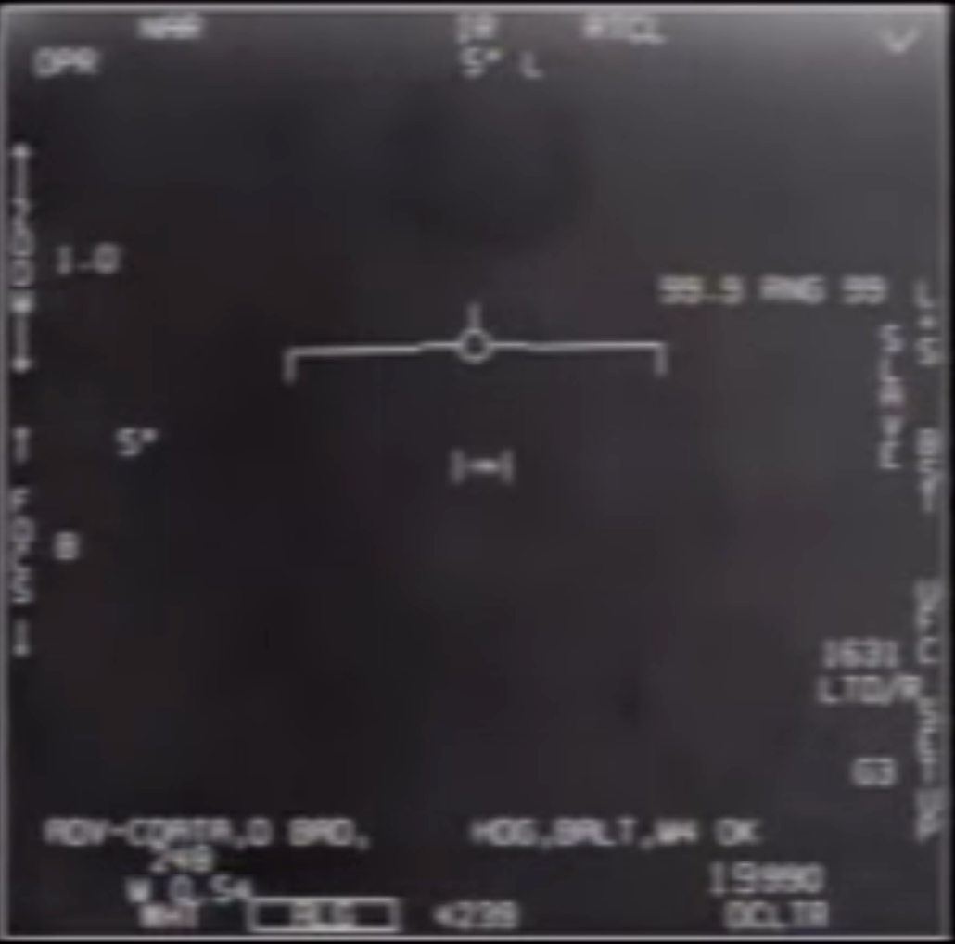
Screen grab from USS Nimitz encounter with tik-tac ufo in 2004 as recorded by Advanced Targeting Forward Looking Infrared Radar
(https://en.wikipedia.org/wiki/File:FLIR1_Official_UAP_Footage_from_the_USG_for_Public_Release.webm)

He notes that 'anti-gravity' is one of their attributes, this is also noted as one of the five observables of Luis Elizondo, who was the former program director of the USDOD Advanced Aerospace Threat Identification Program (AATIP) which existed from 2007-12 which preceded the Unidentified Aerial Phenomena Task Force of the US Office of Naval Intelligence, which itself is superceded by the Airborne Object Identification and Managemenet Synchronization Group (AOIMSG).

When Elizondo ran the Defense Department initiative, called the Advanced Aerospace Threat Identification Program, or AATIP, he compiled a list of extraordinary, logic-defying capabilities most commonly associated with unidentified aerial phenomena sightings. He calls those traits the “five observables”:
Anti-gravity lift: Unlike any known aircraft, these objects have been sighted overcoming the earth’s gravity with no visible means of propulsion. They also lack any flight surfaces, such as wings. In the Nimitz incident, witnesses describe the crafts as tubular, shaped like a Tic Tac candy.
Sudden and instantaneous acceleration: The objects may accelerate or change direction so quickly that no human pilot could survive the g-forces—they would be crushed. In the Nimitz incident, radar operators say they tracked one of the UFOs as it dropped from the sky at more than 30 times the speed of sound. Black Aces squadron commander David Fravor, the Nimitz-based fighter pilot who was sent to intercept one of the objects, likened its rapid side-to-side movements, later captured on infrared video, to that of a ping-pong ball. Radar operators on the USS Princeton, part of the Nimitz carrier group, tracked the object accelerating from a standing position to traveling 60 miles in a minute—an astounding 3,600 miles an hour. According to manufacturer Boeing, the F/A 18 Super Hornet fighter jet typically currently reaches a maximum speed of Mach 1.6, or about 1,200 miles an hour.
Hypersonic velocities without signatures: If an aircraft travels faster than the speed of sound, it typically leaves "signatures," like vapor trails and sonic booms. Many UFO accounts note the lack of such evidence.

Low observability, or cloaking: Even when objects are observed, getting a clear and detailed view of them—either through pilot sightings, radar or other means—remains difficult. Witnesses generally only see the glow or haze around them.

Trans-medium travel: Some UAP have been seen moving easily in and between different environments, such as space, the earth’s atmosphere and even water. In the Nimitz incident, witnesses described a UFO hovering over a churning "disturbance" just under the ocean's otherwise calm surface, leading to speculation that another craft had entered the water. USS Princeton radar operator Gary Vorhees later confirmed from a Navy sonar operator in the area that day that a craft was moving faster than 70 knots, roughly two times the speed of nuclear subs.

Source: Interview with Luis Elizondo, https://www.history.com/news/ufo-sightings-speed-appearance-movement (accessed 5/31/22)

There is a technology that can explain these five observables and that is gravitational technology. The focus of this book is on unravelling the potential gravitational technology that is used by UAPs. One researcher that has looked into this question is that of Jochem Häuser and W. Dröscher as they have remarked, “As gravity-like fields may have come into the realm of physical reality the question arises about the validity of possible sightings of flying machines with enigmatic technology, perhaps based on these fields?” (Häuser & Dröscher, 2021). Häuser and Dröscher are theoretical physicists that work specifically on the problem of gravitational propulsion for space flight. They focused on their work on the 2004 Nimitz tic-tac UAP incident as it is presented as a unexplained event by the DOD. As they explain in a 2021 paper on gravitational propulsion:

In order to answer this question, we need to take an unconventional step: In science, the discussion of Unidentified Flying Objects (UFO) or Unidentified Aerial Phenomena (UAP) phenomena is frowned upon and has been a highly controversial subject for about eight decades, rejected as unscientific, despite thousands of witnesses describing the sightings of UFOs or UAPs. No striking evidence in the form of hardware or DNA has ever been presented. Moreover, no technology improvement has ever been obtained from these sightings. Nevertheless, there are numerous and credible reports from well trained military pilots and also from other military personnel that confirm the existence of flying objects with completely unusual features. We would like to cite the commander of strike fighter squadron, who reports on the so-called Nimitz event, that took place in 2004 and has since been declassified.

There are several videos (e.g., named the 2004 USS Nimitz FLIR1 video) and there is an interview of about 6 min with Cmdr. Fravor detailing his amazing observations. We will not comment on the credibility of the accompanying videos because there is no convincing evidence that these videos, taken by the latest Raytheon infrared sensors, are beyond normal. The unbelievable horizontal acceleration depicted might have been generated by the aircraft movement itself, although looking at the actual pictures this seems less likely.

Instead, we will listen to the report of Cmdr. Fravor, a topgun pilot with 16 years of experience, describing the flying capabilities of the object that he tried to intercept. Here is what he reported: His F/A 18 F Super Hornet was flying at an altitude of about 20,000 feet about 40 miles off the coast of San Diego, when he detected an object the size of a Boeing 737 (estimated size of about 40 feet) in the water below at a depth of some 10–15 feet, moving around erratically. When he descended trying to investigate this object it left the water and he suddenly recognized that the unknown object appeared to mirror his flight maneuvers as if the object had notified the presence of the Super Hornet. Strange enough, the unknown object did not possess any wings, nor could an exhaust plume be detected, when it was moving about with incredible acceleration (as may be visible from the accompanying video), completely outperforming the maneuvers of Fravor’s aircraft. The unidentified craft showed, according to Cmdr. Fravor, a maneuverability that no aircraft on this planet would have, dropping down from a height of 80,000 feet down to 20,000 feet and hovering, then going straight up in virtually no time and disappearing. (Häuser & Dröscher, 2021, pg. 62)

They go on to list the characteristics of the various confirmed UAP incidents as relayed by the US DOD, noting the following properties of these UAPs:

1. No aerodynamic control surfaces,
2. No optimized aerodynamic shape, however, silent
gliding was observed,
3. Extreme acceleration capabilities,
4. Extreme velocities (up to hypersonic flight speed)
5. No visible propulsion system,
6. Relatively small size, no propulsion system
detectable,
7. No sound emission,
8. Remaining airborne for many hours,
9. Hovering and slow motion capabilities (velocities
reported: about 16–70 km/h),
10. Operate both under water and in air,
11. Respond to external light signals.
(Häuser & Dröscher, 2021, pg. 62)

They present an analysis to attempt to reveal the science behind the observed technology, again re-emphasizing that these characteristics are not of any publicly known aerospace technology of today. They list their observables as:

1. Propulsion system: the description by the pilots unambiguously leads to the conclusion that these crafts are working without fuel,
2. Their flying capabilities are independent of aerodynamic control surfaces and do not depend on lift,
3. Pitch, roll, and yaw seem to be generated by a force field which leads to extreme agility,
4. Moreover, reported accelerations are far beyond the tolerance level of any human pilot, and perhaps these vehicles are unmanned, or no acceleration is felt inside such a craft,
5. As the size of the sighted craft was relatively small (40 feet) as stated by Cmdr. Fravor, the field propulsion system that these vehicles appear to have, must also be relatively small,
6. The energy production of these flying objects is unknown, but any imaginable fusion reactor based on today’s technology is out of the question, cf., for instance, the height of the 500 MW fusion demonstrator, Iter, currently under construction in Cadarache, France, is about 30 m while the mass of the vessel is more than 10.00 metric tons etc. Such an enormous structure is not at all compatible with the small volume of those unidentified flying objects.
7. Moreover, as there is no exhaust plume, propulsion based on momentum generation is ruled out,
8. As has been known for more than six decades, any breakthrough in propulsion, in order to become a real game changer, needs to be functioning without fuel. This insight is not at all new, and was already discussed in the book on space propulsion by Corliss, 1960, termed field propulsion, and was actively researched in industry and academia at that time. However, all breakthrough propulsion research programs ended without producing any scientifically usable results,
9. With regard to the four known interactions in current physics, it is clear that short range interactions (strong and weak) cannot be used as the source of such a force field,
10. Electromagnetic interaction is also out of the question because neither in our atmosphere nor in space there exist strong electromagnetic fields. The sole field that remains is gravitation,
11. However, a look at Einstein’s field equations unmistakably shows that gravitational fields cannot be engineered from GR. Einsteinian gravity is far too weak to accelerate large masses, unless we would be moving a neutron star around, a technically completely unfeasible undertaking.
12. It is obvious that present physics does not allow this kind of propulsion as reported by UFO and UAP witnesses.
13. Unless we are claiming that a certain part of our pilots are somewhat insane and hallucinating frequently, we are forced to admit that novel physics must be at play, leading to technical capabilities beyond our imagination.
14. Hence, it is proposed that a second type of gravity could exist, enabling us to engineer gravitational fields with relatively little technical effort, but requiring a new approach to gravity as we already described in numerous articles as well as in our recent book This means that the generation of gravity-like fields outside GR could be considered a physical possibility.
(Häuser & Dröscher, 2021, pg. 63-4)

Returning again to the US Governments investigations of what the government terms UAPs. It is typically reported in investigations of these phenomena that the vast majority turn out to be explainable by quit mundane events, such as weather balloons. However there are a small minority of reports that show unusual and unexplaniable physics behind these phenomena. The governments disclosure of these phenomena being taken seriously by the DoD is noteworthy in-itself. At the House of Representatives Permanent Select Committee on Intelligence, Subcommittee on Counterterrorism, Counterintelligence, and Counterproliferation on May 17, 2022 the issue of how many reports are possibly linked to advanced technology was brought up, a transcript from the hearing reads:

Mr. Schiff (Congressman): Okay. Last year's report also said that of those 144, 18 of them reportedly appeared to exhibit unusual flight characteristics, appeared to demonstrate advanced technology, and some of them appeared to remain stationary and winds aloft, move against the wind, maneuver abruptly, or move at considerable speed without discernible means of propulsion. That is pretty intriguing. And, if you are able to answer this in this setting, are we 28 aware of any foreign adversary capable of moving objects without any discernible means of propulsion?

Mr. Bray (Intelligence Investigator): I think I would -- without discernible means of propulsion, I would say that we are not aware of any adversary that can move an object without discernible means of propulsion. The question then becomes, in many of these cases where we don't have a discernible means of propulsion in the data that we have, in some cases there is likely sensor artifacts that may be hiding some of that. There is certainly some degree of something that looks like signature management that we have seen from some of these UAP. But I would caution -- I would simply say that there are a number of events in which we do not have an explanation in which -- and there are a small handful in which there are flight characteristics, there are signature management that we can't explain with the data that we have. We will continue -- those are obviously the ones that are of most interest to us. Earlier, when we asked about how you avoid technological surprise, the biggest way you avoid technological surprise is by collecting this type of data and by importantly calibrating the assumptions that you go into with how you do that analysis. I will tell you, within the UAP Task Force, we have one basic assumption and that is that, generally speaking, generally speaking, our sensors operate as designed. And we make that assumption because many times these are multisensor collections. We make no assumptions about the origin of this or that there may or may not be some sort of technology that we don't understand. That is, I think, the key to avoiding technological surprises, by calibrating those assumptions.
(US Congress, 2022, Page 28)

In the hearings it was noted that the US is not alone in their investigations:

Mr. Bray: Allies have seen these. China has established its own version of a UAP task force. So clearly a number of countries have observations of things in the airspace that they can't identify.

Dr. Wenstrup (Congressman): And do we share data with some, with all? Are they sharing with us? Mr. Bray. We share data with some, and some share data with us. (US Congress, 2022, pg. 31)

In an earlier report from the US DoD it was reported that out of 144 reports, they had 80 with sensor data, meaning that Radio Frequency signatures were recorded on the sightings. The DoD report relates:

In a limited number of incidents, UAP reportedly appeared to exhibit unusual flight characteristics. These observations could be the result of sensor errors, spoofing, or observer misperception and require additional rigorous analysis

In 18 incidents, described in 21 reports, observers reported unusual UAP movement patterns or flight characteristics. Some UAP appeared to remain stationary in winds aloft, move against the wind, maneuver abruptly, or move at considerable speed, without discernable means of propulsion. In a small number of cases, military aircraft systems processed radio frequency (RF) energy associated with UAP sightings. The UAPTF holds a small amount of data that appear to show UAP demonstrating acceleration or a degree of signature management. Additional rigorous analysis are necessary by multiple teams or groups of technical experts to determine the nature and validity of these data. We are conducting further analysis to determine if breakthrough technologies were demonstrated
(ODNI, 2021, page 5)

Burkhard Heim (February 1925 – 14 January 2001)

One physicist working on the issue of transcommunication was Burkhard Heim. One cannot exclude that perhaps Heim had developed an intuitive ability, which focused his research, as he lived with severe hearing and visual disabilities, disabilites that led him to resign from the prestigious Max Planck Institute for Physics under Wiesacker after receiving his Ph. D. In Physics from Gottingen, after the war the KWI Institutes were renamed after Max Planck. He was a type of misfit wunderkind with chemicals and especially thermite explosives, after a school prank with toy explosives he was kicked out at age 14. He was recruited by Goring after submitting ideals regarding explosives to the Chemical-Technical Institute of the Reich in Berlin-Tegel while serving in the Luftwaffe in Italy, a type of nuclear detonator, then put in touch with Heisenberg, to work on thermite explosive devices for the Wehrmacht, as a very young man, 19, he led his own team. It was his love of thermite that led to his disabilities as he was loading a thermite explosive for testing, a sound alarm warning of air raids, a false alarm, went off. The vibrations triggering the explosives he held in one hand, instinctively he covered his neck with his other hand, both hands were blown off, otherwise he would have been decapitated by the explosion. Luckily, for Heim, aside from covering his neck, the plant doctor was on his one day a week onsite duty, and prevented massive blood loss and saved Heim’s life. (Ludwiger, 2001, 5-6)
Later in 1952 he began lecturing on his ideals regarding a new propulsion system which gave him some momentary noteriety. Which also placed him under surveillance by the intelligence services (Ludwiger, 2001, 9). He received personal and financial support from Ludwig Bolkow of the aerospace and defense contractor, Messerschmitt-Bölkow-Blohm (MBB) starting in 1958, from which he was able to hire an electrical engineer to assist with his experiments short term. The US Government was even interested in Heim, with an early review of Heim theory in the technical publications of the USAF from 1961. One would think that with such patronage as Heisenberg and von Wiezsacker that Heim’s academic credentials would be secured. Heim and his ideals regarding gravity, propulsion and transcommunication have had a steady opposition from the start. One modern example includes a former Physicist, Dr. Holm Hummler he left science in 2001 to works for Boston financial interests, the Boston Consulting Group, He has been the owner and managing director of Uncertainty Managers Consulting GmbH in Bad Homburg, near the banking center of Frankfurt, since 2007 (Hummler, 2018). He goes around specifically debunking Heim theory as pseudoscience and is a self-marketed ‘skeptic’, among other things he ‘debunks’ are technological conspriacy theories. So once again, we find another gravitational theoretical physicist being suppressed and again we see some connection to the same original social networks of the Boston financial interests.
As mentioned in the Jordan section, Jordan and Heim collaborated together. Heim and Jordan were both educated at Gottingen, both have common connections with von Weizsacker, who was imprisoned in Britain for a year after the war as a member of the Nazi Bomb team. Jordan and Heim have extensive theories and emphasize the role of Gravity, both were seeking a physical explanation for transcommunication using gravity. So it is no wonder that they would eventually collaborate. Jordan was in attendance when Heim presented his theoretical physics for a symposium for the staff of German areo-space and defense contractor Messerschmitt-Bölkow-Blohm (MBB) at Ottobrun in 1969. At that time Jordan was a advisor on Aerospace propulsion for MBB and others, important to remember Jordan had won a Gravity Research Foundation (GRF) award for a paper on faster then light propulsion. Jordan and Heim were to conduct a experiment on measuring gravity, but it did not receive sufficient funding at the time and the experiment was superceded by other experiments and never conducted. Like Jordan, Heim also collaborated with the former SS member and scientist Dr. Hans Bender who scientifically investigates psi phenomenon and specifically worked with Heim on a scientific theory of ‘transcommunication’.
Many physicists have come up with hyperdimensional explanations of our physical reality, like Klein-Kaluza theory from the 1930s, the original hyper dimensional explanation. Heim too comes up with a theory based on hyperdimensions, 6d. Ludwiger notes regarding 6d that Roger Penrose has also come up with a similar concept, we will read about Penrose’s ideals on Quantum Consciousness, where gravity plays a role in determining the final Quantum State later:

Incidentally, the mathematician Roger Penrose, Stephen Hawkings' teacher, has come across 3 real and 3 imaginary dimensions of the world as well. He discarded his complex C3-world, as he could not interpret the two additional imaginary dimensions physically. Should there be 3 time dimensions? How should they be discriminated from one another? However, if they are not time directions, what are they? And why can't they be temporal dimensions? Xiaodong Chen, a student of Penrose, found that in a R6 at least the wave-particle-dualism... (Ludwiger 2013)

Heim’s 6 Fundamental Forces: Strong, Electrodynamic, Weak and Gravity in 3 modes; Quintessence, Gravity, Gravitophotons

Another participant at the MBB lectures, at the time an engineer working there, Dr. Illobrand Ludwiger, who later became an adept of Dr. Heim’s theories, has given the following succinct overview of Heim’s contribution to theoretical physics:

- a unified phenomenological field theory in which electro magnetism and gravity have been united by Heim,
- a unified quantum-geometric structure theory that has led to a formula for the calculation of the masses of elementary particles, and
- development of an aspectual logic by means of which both the quantitative-physical as well as the qualitative-organisational part of the world can be uniformly described.

At the end there emerges a new world view with the following predications:
- we live in a 6-dimensional world,
- elementary particles are 6-dimensional, dynamic, metric structures,
- humans, too, are 6-dimensional creatures,
- there wasn't a big bang, but the universe developed from a simple space cell,
- the organization in matter is governed by qualitative structures from the 5th world coordinate, - - an approach for solving the body-mind-problem,
- autonomous structures of consciousness can exist free from a material carrier. (Ludwiger, 2013)

In the 1950s the main achievement for which Burkhard Heim achieved a degree of recognition was his discovery of a new propulsion concept for space flight. According to this concept, it should be possible to have a spaceship powered by specially generated gravitation fields and by conversion of electromagnetic waves – instead of by use of chemical fuels. Heim had discovered a phenomenological explanation of gravity as well as a connection to electromagnetic fields. By analogy with Maxwell’s theory of electromagnetism, he had interpreted gravity as a physical field. (Ludwiger 2013)

Heim notes that, “temporally variable magnetic fields [see Ch. 9] should also be able to generate gravitation fields.” Which is significant in that it presages the ideals of Gerstenshtein Effect by a decade, where EM is turned into Gravity and Gravity into EM. This may also be related to the findings of Dr. Persinger that variable magnetic fields are used in ‘remote sensing’ and ‘deep correlation’.

As mentioned previously, the aerospace defense contractor, MBB, was interested in Heim from at least 1958. He periodically briefed MBB engineers on his gravity based physics. According to former MBB engineer, Ludwiger:

“Only as of 1985 the aerospace company MBB seized on Heim's idea, and wanted to furnish the experimental proof that rotating masses can generate magnetic fields. In a laboratory experiment the weak magnetic field generated by means of a rotating crystal ball should have been proved with a Squid magnetometer, which is a highly sensitive detection device. However, the money necessary for that device couldn't be raised. (Ludwiger 2013)

As noted before Einstein’s GR does not supply a complete answer for the role of Gravity in our Universe, and it still remains in 2020 an open question how Quantum Gravity works exactly. Heim developed a Contrabaric Equation, first formulated in 1955, which is used by other researchers in faster then light propulsion. Ludwiger notes regarding the equation:

As he factored in the field mass of the gravitation field (which Einstein had neglected due to its insignificance), Heim obtained his so-called contrabaric equation. According to that equation, the transformation of electric or magnetic fields into gravitational acceleration fields and vice versa should be possible (Ludwiger, 2013)

It is interestsing that in the 1950s he is already contemplating issues that would later be written of by the likes of Russian Physicist, Gerstenshtein, regarding Gravity in 1962. Yet, there is an almost total absence of knowledge of Burkhard Heim, for reasons such as having to live in isolation due to his disabilites, and not wanting to publish in Academic journals without experimental results to back up his theories. Unfortunately, he did not live into the era we live in now where Gravitational Science is taking off and taken more seriously after the confirmed discovery of Gravitational Waves in 2015, published 2016.
Heim directly worked with transcommunication, which is an important part of any Neuroweapon platform deployed today. He was contacted in 1966 by the parapsychologist Dr. Hans Bender, Ludwiger notes regarding this collaboration:

When in 1966 the well-known parapsychologist professor Hans Bender asked whether he would be willing to help him with his physical knowledge with interpreting the “tape-recorded voices”, Heim agreed. In Sweden, together with his assistant W.-D. Schott, he assessed the claims made by Mr. Jürgenson who heard unexplainable voices on tape and on the radio, voices that seemed to address him personally. As these experiments weren’t performed scientifically correct, Heim himself did experiments in his laboratory, which, however, he only rarely talked about. He despised people who carelessly went public with undistinguished results.
In 2010, the physicist Holger Klein found several hundred manuscript pages in Heim’s legacy in Northeim which had been administered by Heim’s foster daughter Ingrid Hartung until her death in the same year. Not only did these pages contain hundreds of Heim’s experiments regarding the validation of transcommunication, but also approaches for a theory of transcommunication. No mainstream physicist would ever dare to start such a kind of work.
As in the 6-dimensional theory all physical field sizes are 6-dimensional, too, Heim derived a possible influx of the additional components x5 and x6 to the moduled phonetic sequence density from the 6-dimensional radiation vector that is transmitted by radio stations. He did this in such a way that in considering the required aerial properties for the trans-components of the radiation vector a modified spoken text can be received as a matter of principle.
In doing so, Heim created first approaches for theoretically comprehensible experiments of a paranormal kind. (Ludwiger, 2013)

Yet, it gets weirder for Burkhard Heim, as has been indicated with other scientist, some feel that they are interacting with a superior intelligence while researching and being in a sense directed in their research. Heim while working on his Logics, he was working on ‘Syntrometric Telecentrics of Maximes’, a book on formal logic, that was unpublished but presented at MBB in 1976 with Jordan present, he speaks of being in communication with an extrinsic intelligence, which of course would match the description of a Targeted Individual who hears either positive or negative feedback from ‘voices’:

The work on it was so difficult for Heim that sometimes he himself was not able to understand himself anymore. On July 19, 1974 Heim talked about his experiences ....
‘As I cannot write, I dictated the derivations I did in my head to my father, walking up and down in the room. And during this, I sometimes got a very strange feeling: I couldn’t say “I’m dictating this” and “I’m thinking this”, but “IT is dictating. IT’s thinking!” It was something that apparently didn’t belong to me at all. It seemed to me as I was only repeating something that actually belonged to something completely elsewhere. That’s a weird feeling! I have never talked to anybody about this, as I said to myself, nobody would understand anyway. (Ludwiger 2013)

Sometimes – and that’s the most creative moments you can have as a human being – you have the feeling as if you’re only the tool and you say, dictate or write something that actually doesn’t originate in you. That has happened to me more than once while I was dictating these notebooks that I later further worked on in more detail. I always had the feeling that completely foreign thoughts were approaching me which only had to be recorded. But I was never able to tell where that came from. That only happened some times, strangely always in such moments where it seemed that I was at a loss. Then it happened.” (Ludwiger 2013)

As can be seen from Burkhard Heim’s studies and findings the science of Transcommunication is directly related to Gravity. Later, other researchers picked up on Heim’s original theories. Dröscher and Häuser have used his theories to create ‘Extended Heim Theory’ (EHT). They even won an award, American Institute of Aeronautics and Astronautics' Future Flight prize, for a paper in 2010 that argues for faster then light propulsion based of this. However, it would take some x-ray generation, pulsed high power beam, to get it done as Roger Lenard of Sandia Labs has stated regarding the proposal:

*Roger Lenard, a space propulsion researcher at Sandia National Laboratories in New Mexico does think it might be possible, though, using an X-ray generator called the Z machine which "could probably generate the necessary field intensities and gradients". (Haines 2006)

Although this is one way of doing new propulsion, it may or may not be the way. Without adequate funding for experimentation we may never know if Heim Theory is accurate or innacurate, as it has not been tested it is too early to be a protaganist or antagonist of the Heim Theory. As knowledge and interest in working with gravitational technology is relatively new and under researched since it took so long to even confirm their existence, an entirely different or unknown process may emerge from gravitational research, especially at the quantum level, that may be the real answer. Although, it is true many supporters of UFO encounters claim that different governments in the world already have this technology if it is gravitational based then when it exists may be completely irrelevant, with the real question who has the capability?

In a July, 1940, interview with The New York Times, Nikola Tesla claimed to have invented a device that produced a “tremendous repelling force” by catapulting “microscopic electrical particles” into space. This “teleforce” beam, per Tesla, would be capable of “eliminating high vacuum”. “The Phonon Maser”, Townes writes: “Acoustic waves follow equations that are of the same general form as the equations of light and manifest many of the same phenomena. An acoustic wave can produce an atomic or molecular excitation, or receive energy from it by either spontaneous or stimulated emission. Hence, one may expect maser action for acoustic waves if a system can be found in which molecules are sufficiently coupled to an acoustic field and appropriate excitation can be found to find the threshold condition”. Production of Coherent Radiation by Atoms and Molecules. Charles H. Townes. Nobel Lecture. Dec. 11, 1964.

Notes:

Jochem Häuser and Walter Dröscher Extended Heim Theory

Jochem Häuser in video presentation states that he became interested in this work when MBB approached his employer the European Space Agency for funding for a gravitational experiment. MBB had 10 physicists working on this, when the company was sold, all the physicists were fired, MBB had a secret project with a group of 10-11 physicists,“books closed”. He has been working on EHT since 2002. h8 corresponds to the non-linear sigma model in mathematics. All attempts to generate extreme gravitational fields using General Relativity have not worked, maybe we can extend General Relativity. Whereas Tajmar uses a ring, Häuser uses a coil in his proposed experiment, producing a strong. vertical field. There should be a measurable effect. The engineering involved once the physics is understood is much simpler then contemporary rocket fuel propulsion. Estimates an investiment of 2-3 million euros to investigate the theories or models experimentally.
https://www.youtube.com/watch?v=8wIVckxMQos

Gravity beyond Einstein? Part I: Physics and the Trouble with Experiments DOI 10.1515/zna-2016-0479 Received December 15, 2016; accepted March 30, 2017; previously published online April 29, 2017

GRAVITY BEYOND EINSTEIN? PART II: FUNDAMENTAL PHYSICAL PRINCIPLES, NUMBER SYSTEMS, NOVEL GROUPS, DARK ENERGY AND DARK MATTER, MOND Preprint · February 2019

Gravity beyond Einstein? Part III: numbers and coupling constants, contradictory experiments, hypercomplex gravity like-fields, propellantless space propulsion https://doi.org/10.1515/zna-2021-0147 Received May 29, 2021; accepted October 3, 2021; published online November 4, 2021

criticize the lack of confirmation through LHC and other experiments of dark energy and dark matter as well as higher dimensional (supersymmetry and string theory) physical evidence, proposing an alternative which is hypercomplex numbers which gives hyper complex matter. Like, Fontana, they propose a dual space or hidden space where dark matter resides. “In view of this contradicting outcome, we suggest a four dimensional Minkowski spacetime, assumed to be a quasi de Sitter space, dS1,3 , complemented by a dual spacetime, denoted by DdS^{1,3} , in which the dark matter particles that are supposed to be of negative mass reside. This space is endowed with an imaginary time coordinate, −it and an imaginary speed of light, ic. This means that time is considered a complex quantity, but energy m(ic) 2 > 0. With this construction visible and dark matter both represent positive energies, and hence gravitation makes no distinction between these two types of matter. As dark matter is supposed to reside in dual space DdS^{1,3} , it is principally undetectable in our spacetime. That this is evident has been confirmed by numerous astrophysical observations” pg. 13

de Sitter spacetime is the maximally symmetric spacetime of constant positive curvature

dark matter only interacts with the visible universe through gravity or in EHT gravity like bosons.
Dark energy, EHT has two dark energy particles: v⁻_{de} and v⁺_{de}
Three types of gravity couplings in EHT, Gp, Gn, Gg:

Two Types of Gravity in EHT: “in EHT there exist two types of gravity, cosmological and canonical gravity, mathematically represented by the two groups, SU(2)_{GN} and SU(2)_{G} (see Part II, Eq. (16)) for the respective gravitational bosons. This is a formal aspect only, and it is felt that only group SU(2)G may represent real spin-1 bosons, whereas cosmological gravity could be a geometric theory” pg. 45, note 20.

Einstein gravity, cosmological gravity of GR, is different from the other three forces, canonical gravity which is a product of hypercomplex gravity fields which result from canonical gravity. “In canonical gravity (repulsive pg19) the conversion of electromagnetic into gravity-like fields (as surmised by Faraday and Einstein) should be possible, but not in cosmological gravity (hence these attempts did not succeed), and thus these conversion fields are outside general relativity”
In EHT there are five gravitational constants G_{E}, G_{N}, G_{p}, G_{gp}, G_{q}
Canonical Gravity:
“hereas Cooper pairs constructed from hypercomplex muons j? are believed to generate hypercomplex magnetic charges that eventually are converted into axial gravity-like fields BG mediated by spin-1 bosons (hence the name canonical gravity) as suggested in the Heim experiment. Therefore, a second and much stronger type of gravity should exist that behaves similar to the three other fundamental forces.” pg. 25

“An interaction between electromagnetism and hypercomplex-gravityis predicted, mediated by three additional hypercomplex-gravity bosons also called canonical gravitational bosons. These gravitational bosons (spin-1 bosons) of the second SU(2)G group (EHT groups, Part II, Section 5), are the source of canonical gravity [108], i.e., the type of gravity whose interaction with other fields is mediated by bosons. Hence it is termed canonical. Canonical gravitational fields31 mediate much stronger gravitational fields than (geometric Einsteinian) cosmological gravity and are supposed to result from an interaction with electromagnetism, which might have been produced inadvertently in the Gravity-Probe B experiment pg. 53

As an interaction of electromagnetism and canonical gravitation (spin 1 bosons) outside GR is deemed to take place by the photon γ and the gravitophoton v_{gp}, where the latter (representing the Bℍ field) is the gravitophoton that is responsible for the interaction with the spacetime field. pg. 73

Apart from the four families of particles and 15 quarks predicted by EHT, another major modification of the SM comes from the existence of extreme gravity-like fields (canonical gravity). These fields interact with the other three physical forces but also with the ubiquitous dark energy field. pg. 80

Cosmological Gravity (Einsteinian GR):
cosmological gravity (GR), as described by Einstein, is a purely geometric theory (hence its weakness), and is formally represented by group SU(2)_{G} . Instead, cosmological gravity seems to be mediated by spacetime curvature and not by field bosons, and thus is called cosmological gravity being fundamentally different from canonical gravity. pg. 53 note 31
If the picture of QFT is correct, then there should be a major difference concerning the gravitational interaction between elementary particles with respect to Einstein’s view that is related to the curvature of spacetime and not on the exchange of carrier bosons in the form of gluons. Einstein’s gravity (or cosmological gravity) works without any bosons, despite the group S(2)GN . 34 This is in major contrast to QFT pg. 56

Therefore, it must be concluded that Einstein’s original point of view that GR is a geometric theory is the correct one. Consequently, the search of spin-2 gravitational bosons or gravitons seems to be futile. So, it appears that there is a basic difference between cosmological gravity and the other three fundamental forces in that this type of gravitation is not mediated by bosons, but is of geometric origin, namely, as suggested by Einstein in 1915. In GR the gravitational force is caused by the curvature of space. This is correct only for cosmological gravity as conceived by Newton and Einstein, which is due to the origin of mass, but would not be true for gravity that follows from spin-1 particles, as suggested by EHT resulting from the conversion of electromagnetic fields into extreme gravitomagnetic or gravity-like fields pg. 58

Einstein’s cosmological gravity fields are represented by geometry which are coupled through the equivalence principle of gravitational and inertial mass, but not by the exchange of bosons. It is highly questionable whether the cosmological gravitational fields of GR are represented by bosons, and thus spin-2 gravitons may exist only in form of a mathematical description pg. 78

Gravitational fields can be safely ignored in elementary particle physics because in natural units the coupling constant of Newtonian gravitation isGN = 6.707 × 10−57 eV −2 whereas in SI units the value is GN = 6.673 × 10−11 kg m3 s−2. Hence, expressed in natural units, i.e., c = 1, ℏ = 1, kB = 1, and ?0 = 1, GN is incredibly small and entirely negligible with respect to the three other interactions as described by the standard model of particle physics. The situation becomes completely different if gravity-like fields are generated. pg. 78 note 50

Symmetry Groups of EHT:

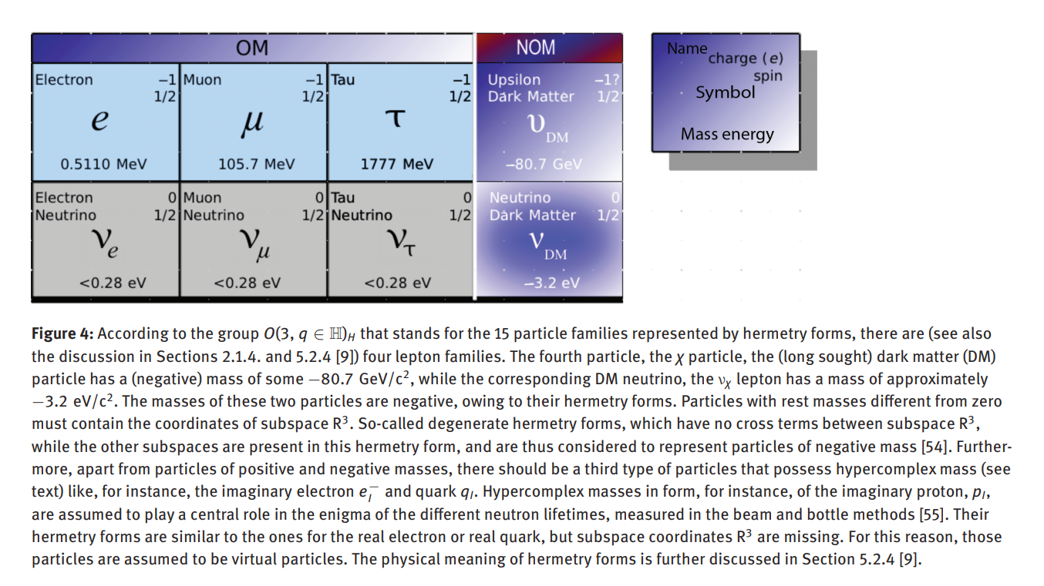
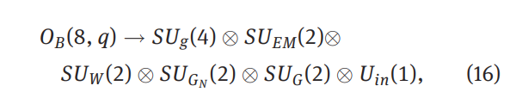
equation 16 from pg. 419 of Part II.
where the group OB(8, q) comprises all existing physical field quanta. The subgroups SUGN (2) with three and SUG(2) with three generators are containing the three gravitational bosons of the cosmological gravitational fields (Newtonian gravity) and the three gravitational bosons representing the hypercomplex-gravity fields, resulting from the conversion of electromagnetic into gravitational fields as described above (Fig. 6). The group OF(8, q) represents both the fermions of OM and NOM (negative and imaginary matter) pg. 419 of Part II
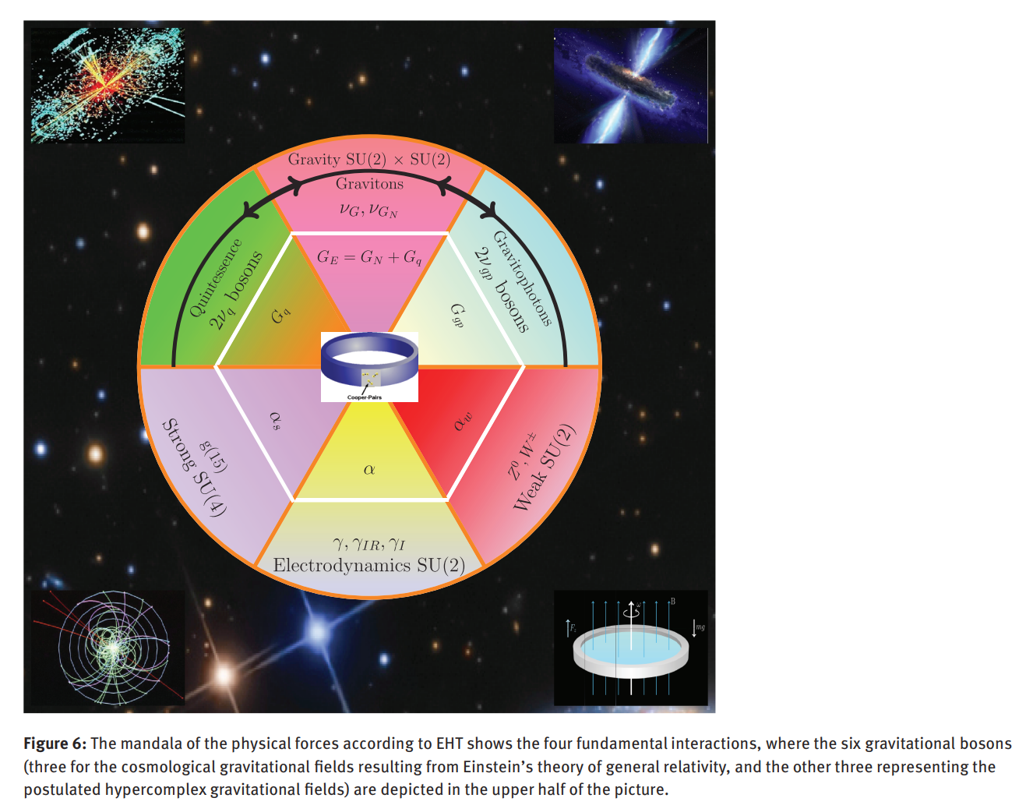
hypercomplex numbers are used as the foundations for the formation of the symmetry groups.

Gauge symmetries: These are local symmetries that act differently at each space-time point xµ = (t,x) . They create particularly stringent constraints on the structure of a theory. For example, gauge symmetry automatically determines the interaction between particles by introducing bosons that mediate the interaction. All current models of elementary particles incorporate gauge symmetry. (Details on p. 4)

SU(2) describes the (broken) Isospin symmetry of the Weak Interaction. 3 Pauli matrices σi Ji = σi / 2 3 bosons W+ ,W− ,Z 1 diagonal Ji J3 (z-component of the isospin)

A coupling constant (or an interaction constant) is a parameter in the field theory, which determines the relative strength of interaction between particles or fields

t in EHT gravitation is characterized by a total of five gravitational constants G_{E}, G_{N}, G_{p}, G_{gp}, G_{q} in combination with two SU(2) groups (Part II, Eq. (16)) obtained from the set of hypercomplex numbers that give rise to six gravitational particles to be explained further in Section 2.3, where the three generators of group SU_{GN} (2) (see Section 5.4 of Part II) characterize the three cosmological gravitational fields of GR with possible bosons (i.e., if the QFT concept, meaning that bosons act as force mediators was preferred over the classical curvature approach of GR). In this case we may conceptualize three gravitational bosons in GR, in contrast to hypercomplex gravity proposed herein, namely v_{GN} (ordinary matter), v_{gp}(gravitomagnetic interaction), V_{q} (interaction between matter and the dynamic spacetime field).
The second group, SU_{G}(2), describes three gravitational bosons outside GR accounting for extreme gravitomagnetic fields as they might have been seen in the original experiments by Tajmar et al., Graham, or Gravity Probe-B. These bosons are denoted by v_{G}, spin-1, v_{gp}, spin1, v_{q}, spin-0, and are assumed to trigger an interaction, that is, a conversion at a critical temperature T_{C} from electromagnetic to gravitomagnetic or gravity-like (acceleration) fields characterized by the coupling constant (see next section) α_{gp} ≈ 1∕212, most likely upon symmetry breaking at cryogenic temperatures upon symmetry breaking, where spin ice materials could be instrumental. Hence, these three particles are sometimes referred to as cold (or canonical) gravitational bosons.
[ Diamantini, Univ. of Perugia [39], stated that at cryogenic temperatures magnetic monopoles are produced and can form a Bose condensate ]

...the setup of the Heim experiment is outlined, whose success of course depends on whether Nature has a hypercomplex side in the form of novel hypercomplex matter. Hypercomplex numbers are an indispensable part of the description of hypercomplex matter, deemed to be instrumental for the generation of gravity-like fields outside GR. pg. 17

In order to calculate the coupling constants from numerical formulas, first the concept of ordinal numbers is used that are associated with their corresponding number system. For instance, there are the hypercomplex numbers Oℍ (simplest noncommutative algebra), octonions O? (or Cayley numbers, eight-dimensional, nonassociative algebra), or even the sedenions O? (extending the 8-dimensional Cayley algebra into a 16-dimensional noncommutative and nonassociative algebra over the real numbers. A hypercomplex number is represented as q :=x + yi + zj + wk, where i, j, k are the base vectors. In EHT we associate these base vectors with hypercomplex leptons e⁻i, μ⁻j, and τ⁻k. According to our interpretation hypercomplex electrons might have been seen in the experiments by Tajmar et al., Graham, and Gravity Probe-B leading to extreme gravitomagnetic fields with coupling constant α_{gp}. In the Heim experiment we expect to see hypercomplex muons μ⁻j that are supposed to be able to generate a collective phenomenon that mimics a magnetic monopole (see below). Upon conversion, the hypercomplex muon gives rise to an axial gravity-like field with a coupling constant (Heim field) α_{3G} > α_{2G} (GP-B). pg. 19

Two sets of ordinal numbers can be constructed utilizing the basis vectors of the hypercomplex numbers (or octonions and sedenions). The set of ordinal numbers obtained from hypercomplex numbers, O_{ℍ} is employed to calculate α (coupling constant for electromagnetic fields) and α_{gp} (coupling constant for extreme gravitomagnetic fields..... It should be noted that the coupling constants are the square of probability amplitudes.

The language of Nature seems to be written in numbers. In this regard the elements of a set of ordinal numbers O can be considered the letters of the alphabet of Nature, while different sets of ordinal numbers denote the key words. The coupling constants then can be considered as the sentences according to which Nature actualizes the transformation from the realm of pure numbers to the physical world. pg. 20

The three gravitational interactions of EHT have three different gravitational coupling constants:
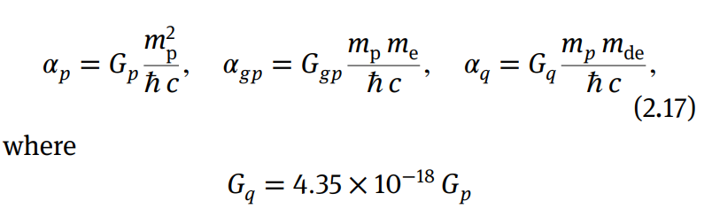
α_{p} describes gravitational interaction among hadrons, α_{gp} describes gravitational interaction between hadrons and leptons, while α_{q} stands for the gravitational interaction between hadrons and dark energy particles. Surprisingly, as a result from QFT, the lepton–lepton gravitational attraction in Newtonian or Einsteinian gravity (mediated by spin-2 bosons) turns out to be zero pg. 21

In GR the gravitational constant comprises three parts, namely Gp (gravitational constant for hadron–hadron interaction (i.e., baryons and mesons, made from quarks, subject to the strong interaction), Ggp (gravitational constant for hadron–lepton interaction), and Gq (gravitational constant for hadron-spacetime interaction), and is given by the equation
G_{E} = G_{p} + G_{gp} + G_{q}, (2.18)
where G_{E} differs from Newton’s coupling constant G_{N} by the (small) value G_{q}.

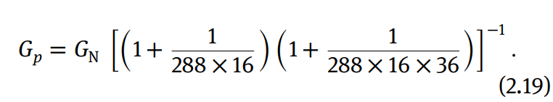

For all practical purposes this difference can be neglected. Hence, Newtonian interaction of matter is determined by
G_{N} = G_{p} + G_{gp}, (2.20)
which is the gravitational coupling constant according to Newton’s theory of gravity, based on the concept of an absolute time and space (i.e., space is considered a container of matter). Hence, the dark energy field and matter (energy) cannot interact in Newton’s theory. This means that Newton’s portrayal with GN as an invariant gravitational constant is no longer correct in principle. Instead, Einstein’s gravitational coupling constant GE needs to be used.

Space-time Grid:
On the other hand, a grid spacing of 10⁻⁴⁸ m would be a sign of an extremely rigid and stable spacetime lattice, which is confirmed by the existence of only tiny ripples from gravitational waves, meaning that even the merger of black holes can be described by linear gravitational theory.
Hence, major distortions of the spacetime lattice in order to be achieved by any advanced technology are unrealistic, and, in particular, warping of spacetime most likely cannot be achieved by any technical means. Obviously, the theoretical predictions from quantum gravity or loop quantum gravity are not in accordance with experiment, which seems to be the rule rather than the exception with all advanced physical theories beyond the SM. Compared to the simulation results of CDT (Loll and Ambjorn et al.), at a length scale of 10⁻⁴⁸ m spacetime has ceased to be four-dimensional, and should have separated into two-dimensional subspaces, that is, there are spectral dimensions of dimension two. Therefore, it may be that four-dimensional quantum gravity is not needed. Page. 24

Moreover, if general relativity is valid down to the scale of about 10−48 m, as suggested by the ESA Integral satellite data, the Planck length is at least 1013 times larger, and there is no need to quantize gravity. In that case, gravity can be kept classical while particle physics is to be described in the form of quantum field theory.

Hence, at a length scale of 10−48 m matter does no longer exist as is known from particle physics. That length scalemay alsoindicate the spacetime grid spacing at which space becomes discrete. In other words,mightit be possible that radiation corrections at this length scale have ceased to exist? pg. 25

It should be kept in mind that the concept of metric means that spacetime is continuous. As we already know at the lowest spatial level spacetime has to be quantized (i.e., comprises discrete elemental space volumina) and it is necessary to add the additional physical features that follow from the concept of spacetime lattice. These properties must not be neglected, for they have an important physical meaning, leading to our model for a discrete of spacetime, termed the Ising model.

There is a fundamental difference between a continuum and a lattice, the latter giving rise to a novel physical phenomenon. Any lattice (mesh or grid), depending on its grid spacing, is subject to the well-known aliasing effect, which is a purely discrete phenomenon. This means that all wave lengths smaller than the grid spacing (Planck length for the spacetime grid or a lattice spacing even smaller than 10−48 m as measured by the ESA Integral satellite) cannot be resolved by the grid and consequently must reappear in the form of altered waves having wave lengths of at least twice the minimal grid spacing. If such a process occurred, energy conservation would most likely require particle production. In other words, the grid only can support a maximal finite frequency. pg. 44-5

In addition, owing to the principle of quantum fluctuations in conjunction with the idea for the existence of oriented elemental surfaces, meaning surfaces with spin (orientation), that is, the spacetime lattice could be considered a spin field and hence the Ising model could be used for its discrete description, (cf., the so-called metron concept introduced by B. Heim in the 1950s). These elemental surfaces are forming the basic building blocks of the space lattice, i.e., the Universe appears to be built from nothing. It is assumed that the first metron was caused by an initial quantum fluctuation. This, then, triggered a chain of events (generating more metrons) – governed by the duality principle and energy conservation – that eventually led to the evolution of the Cosmos... page 45

It is noted that the atoms of space are supposed to be forming a fully entangled lattice. pg. 50

Mass Flavor:
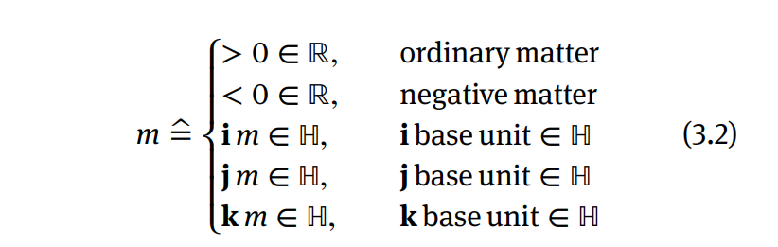
where the base unit j must not be confused with current density j and it is assumed that negative mass represents dark matter and hypercomplex masses ime, jm?, km? may be generated that belong to the category of virtual particles which are always created in pairs, e.g., +im and −im etc. These particles may be produced during a reaction, acting as some kind of catalyzer, but owing to their ephemeral nature, they are off-shelf. See Section 4.2.1 for the family of four leptons. One of the most striking features of hypercomplex particles, e, ie, j? that are representing real, and imaginary electrons as well as hypercomplex muons, j?, may be that they are responsible for novel transition phenomena where superconductivity is just the tip of the iceberg. Page 25

Experimental Setup:

In the Heim experiment the conversion from electromagnetism to gravitomagnetism is supposed to follow the sequence of reactions, starting from photons:

The v_{G} graviton confers the momentum to the space vehicle, the v_{q} provides the opposite momentum to the surrounding dark energy field, which in turn causes spacetime to expand. The total momentum of the physical system remains unchanged, i.e., zero. Because of the importance of this effect, it should be repeated once more: the momentum transmitted to the spacecraft does not result from the conversion of electromagnetic into gravitomagnetic fields. Instead, it is the gravitophoton v_{gp} that triggers an interaction between matter (spacecraft) and spacetime (dark energy). The space craft is propelled at the cost of spacetime motion (expansion). Hence, this kind of propulsion does not need to supply the kinetic energy for the moving spacecraft and thus, it is propellantless. pg. 26

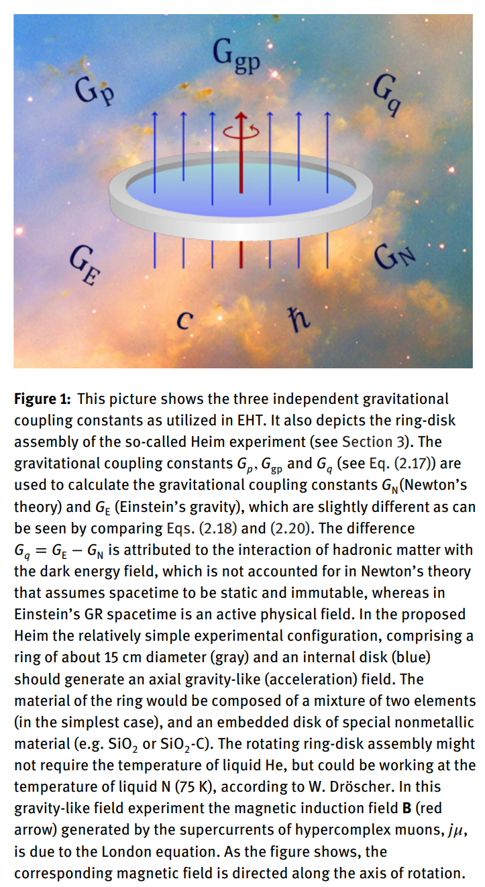
For the Heim experiment a Ca–Te ring as depicted in Figures 1 and 2 (see also Figure 3 in Part I) is utilized, where the interior disk7 is made from Cr (as no experiments have been carried out yet, the materials suggested are recommendations only) and is fixed to the ring, which has a diameter of about 15–17 cm and a quadratic ring cross section of about 1.5 cm2 is suggested. The ring-disk combination would be rotating at a velocity of some 50 m/s at ambient temperature, provided the chosen material composition would result in a symmetry breaking at this temperature level. Cryogenic temperatures are needed in the case of Tajmar’s experiments where symmetry breaking is supposed to produce pairs of imaginary electrons ime, whereas in the Heim experiment pairs of hypercomplex muons are supposed to be generated in the form of emergent magnetic monopoles that, upon conversion, will result in an axial gravitational force with an acceleration magnitude of about 10−3 g. pg. 26
The ring material should be made of spheres of about 3mm diameter. This has the advantage of producing n-current loops that can be arranaged in a matrix like scheme.

Robert L. Baker (2002) http://www.drrobertbaker.com/EuropeanLecture2002.htm
4.1 Propulsion:
Landau and Lifshitz (1975), in The Classical Theory of Fields, on page 349 state:“Since it has definite energy, the gravitational wave is itself the source of some additional gravitational field... its field is a second-order effect ... But in the case of high-frequency gravitational waves the effect is significantly strengthened ...”Thus it is possible to change the gravitational field near an inanimate object by means of HFGW and move it.
Bonner and Piper (1997), in their paper entitled “The gravitational wave a rocket” state:“Loss of mass and gain in momentum arises ... because of the emission of quadrupole or octupole GW.”Thus, according to them, one has the potential of propelling a craft by means of GW.
Fontana (2000), in his paper entitled “Gravitational radiation and its application to space travel” quotes theories that predict GW can be employed for propulsion, that is, the generation of space-time singularities (see also Ferrari, et al, 1988) with colliding beams of HFGW and a form of “propellantless propulsion.”The concept is that HFGW energy beamed from off board can create gravitational distortions, that is, “Hills” and “Valleys” that the spacecraft or other vehicle is repelled by, or “falls into,” or falls toward. Again, HFGW is proposed as propulsion means!

M Tajmar
experiments in gravitoelectromagnetics, gyroscopes, etc. space propulsion

https://arxiv.org/search/gr-qc?searchtype=author&query=Tajmar%2C+M

phonon maser patent: https://patents.justia.com/patent/20080020935

BACKGROUND OF THE INVENTION

The possibility of projecting a coherent beam of high energy at great distances has interested many physicists. The first step toward this goal was understanding the physical nature of the vacuum.

In 1887, the Michelson-Morley experiment showed that the Earth's motion does not cause winds in a light-carrying medium in space. For some time, this result was misinterpreted as indicating that the vacuum of space is absolutely empty. In December 1900, Max Plank published a paper that outlined the law of black-body radiation, thus giving birth to quantum mechanics.

In 1916, building upon this law, Albert Einstein created the foundation for the invention of both the maser and, later, the laser with his concepts of spontaneous and induced emissions. In 1911, Heike Kamerlingh-Onnes chilled mercury to superlow temperatures and found that electrical resistance vanished at 4.2 K. He called this stange physical state superconductivity winning the 1913 Nobel Prize in physics for this work.

In 1932, a series of experiments performed by Carl D. Anderson proved that absorption of a Gamma-ray energy quantum of 1.02 million electron volts (1.02 MeV) in any point of space makes a free electron and positron pair to appear. When such a pair of particles disappears in any point of space, there are at least two quanta emitted, with a total energy of 1.02 MeV. This means that radiation turns into electrons and positrons, and that electrons and positrons, in-turn, annihilate into energy (radiation).

In a July, 1940, interview with The New York Times, Nikola Tesla claimed to have invented a device that produced a “tremendous repelling force” by catapulting “microscopic electrical particles” into space. This “teleforce” beam, per Tesla, would be capable of “eliminating high vacuum”.

In the late 1940s, H. B. G. Casimir proved that the vacuum is neither particle- nor field-free. It is a source of zero-point-fluctuation (ZPF) of fields such as the vacuum gravitational field. ZPF fields lead to real, measurable physical consequences such as the Casimir force.

In 1953, Charles H. Townes, James P. Gordon and Herbert J. Zeiger produced the first maser, a predecessor to the laser. The maser, unlike the laser, projected microwave (rather than optical) radiation. In 1957, Charles Townes and Arthur Leonard Schawlow of Bell Labs, simultaneously with Gordon Gould, proposed the idea of an optical maser, later called laser. This invention established a new field in physics and industry. However, applications of lasers, especially in the Earth's atmosphere, are limited by beam dispersion due to collisions of photons with the molecules comprising air. Furthermore, the laser and maser provide only light and/or heat. Thus, the applications of these two devices are limited to these two effects.

In his Nobel Prize lecture, Townes anticipated that phonons could also be mased. In the last chapter of this work, this chapter titled “The Phonon Maser”, Townes writes: “Acoustic waves follow equations that are of the same general form as the equations of light and manifest many of the same phenomena. An acoustic wave can produce an atomic or molecular excitation, or receive energy from it by either spontaneous or stimulated emission. Hence, one may expect maser action for acoustic waves if a system can be found in which molecules are sufficiently coupled to an acoustic field and appropriate excitation can be found to find the threshold condition”. Production of Coherent Radiation by Atoms and Molecules. Charles H. Townes. Nobel Lecture. Dec. 11, 1964.

Also in 1957, Bardeen, Cooper and Schrieffer published a paper on their quantum-mechanical theory of how, at very low temperatures, the formation of electrons into pairs (hence Cooper pairs) permits superconductivity in some materials (“Microscopic Theory of Superconductivity”, J. Bardeen, L. N. Cooper and J. R. Schrieffer, Physical Review 106, Issue 1-1 Apr. 1957, pp. 162-164). For this new theory, its authors were awarded the 1972 Nobel Prize in physics.

In the early 1970's, Menahem Simhony hypothesized that the vacuum of space is permeated by a three-dimensional crystal lattice. Earlier in his career, Simhony assumed that this crystal lattice included (real) electrons and holes. Later on, Simhony thought that (real) positrons were also present in the crystal vacuum lattice. (“Invitation to the Natural Physics of Matter Space and Radiation”, M Simhony, 1994 published by World Scientific Publishing Co. Pte. Ltd. ISBN 981-02-1649-1). According to Simhony, a cubic millimeter of vacuum lattice contains 6×1033 electron-positron pairs with a combined binding energy of 27×1015 kW. Simhony calculated the binding energy of each cell to be 1.02 MeV. By analogy with ionic alkali halide salts (sodium chloride in particular), the dimension of each side of the unit cube comprising 2 electrons and 2 positrons of the face-centered cubic lattice at rest has a lattice constant of 4.4 (±0.5)*10−15 m.

The majority of scientists, however, believe that most of the vacuum-permeating positrons and electrons are not real (massive) but virtual (pure energy). The virtual particles are merely fluctuations of vacuum energy. To these scientists, the Casimir effect and, possibly, gravity and repulsion, are proofs of the existence of this energy. Unlike Simhony, these scientists believe that the density of real electrons and positrons in the vacuum is very insignificant. A manifestation of the relative sparsity of these electrons and positrons is in the small positive value of the cosmological constant.

In the 1991 U.S. Patent Application #5012302, Herb Goronkin disclosed a phonon generator that promotes the formation of Cooper pairs in a superlattice. The particulars of the disclosed device permit Cooper pairs to form and exist at temperatures that are typically too high for superconductivity.

In the early 1990s, Ning Li and D. G. Torr described a method and means for converting an electromagnetic field into a gravitomagnetic field. Li and Torr suggested that, under the proper conditions, the minuscule force fields of superconducting atoms can “couple”, compounding in strength to the point where they can produce a small repulsive force (“Effects of a Gravitomagnetic Field on Pure Superconductors”, N. Li and D. G. Torr, Physical Review D, Volume 43, Page 457, 3 pages, 15 Jan. 1991).

A series of experiments, performed in the early 1990's by Evgeny Podkletnov, reportedly resulted in a reduction of the weight of objects placed above a levitating, rotating superconductive disk subjected to high frequency magnetic fields. (“Weak Gravitational Shielding Properties of Composite Bulk YBa2Cu33O(7-x) Superconductor Below 70K Under E. M. Field”, E. Podkletnov, LANL database number cond-mat/9701074, v. 3, 10 pages, 16 Sep. 1997). The drawback of the technology described in Podkletnov's above-mentioned paper is the weakness of the resulting effect. Even though Podkletnov has reported 0.3%-to-2.1% weight reduction with the device described in the above-mentioned 1997 paper, many scientists point to a likelihood of error in Podkletnov's measurements.

In 2003, Randall Peters hypothesized the possibility of creating a phonon maser based on “mechanical oscillations by stimulation of excited states”. Peters suggested that the acoustic memory experiments of 2002, and the optically driven pendulum experiments of 1996, would lead to a practical phonon maser. Per Peters, the mechanism of this maser would depend on the metastability of defect-structure organization (“Friction as Basis for a Phonon Maser”, Randall D. Peters, arXiv:physics/0308032 v18 Aug. 2003, http://arxiv.org/html/physics/0308032).

In 2005, Dröscher and Häuser proposed that the vacuum includes attractive and repulsive particles that cause gravitational effects. A particle and antiparticle are generated in a pair from the vacuum itself by the effect of vacuum polarization by virtual electrons, under the presence of a very strong magnetic field. Due to particle pair production, the total energy extracted from the vacuum is zero. (“Heim Quantum Theory for Space Propulsion Physics, for Space Propulsion Physics”, Walter Dröscher and Jochem Häuser AIP Conference Proceedings—Feb. 6, 2005—Volume 746, Issue 1, pp. 1430-1440).

In the November 2005 U.S. Pat. No. 6,960,975, I disclosed a space vehicle propelled by the electro-magnetically changed properties of vacuum, particularly the pressure of inflationary vacuum state. A cooled hollow superconductive shield of the vehicle is energized by an electromagnetic field resulting in the quantized vortices of lattice ions projecting a gravitomagnetic field that forms a spacetime curvature anomaly outside the space vehicle. The spacetime curvature imbalance, the spacetime curvature being the same as gravity, provides for the space vehicle's propulsion.

A few days later in November 2005, Robert Park dismissed my invention as an inoperable. He told NATURE Journal: “If you design an anti-gravity machine, you've got a perpetual-motion machine . . . Shield half of a wheel from gravity and it will keep turning forever” (“Antigravity craft slips past patent officers” by Philip Ball, Nature 438, 139, 10 Nov. 2005). Park failed to notice that the space vehicle of my invention employs a powerful nuclear plant that develops energy greater than the gravitational pull by the height to which the vehicle is lifted.

In his examination of my November 2005 patent, Jack Sarfatti noticed that the “lattice ions” should be defined as Cooper pairs. Sarfatti also suggested that the gravitational effect is very weak (“Dr. Jack Sarfatti's comments on the U.S. Pat. No. 6,960,975 Volfson”, http://marsdrive.com/node/194).

Also in November 2005, scientists led by Clovis de Matos and Martin Tajmar and funded by the European Space Agency, published a paper on their research of gravitomagnetism. They measured the gravitational equivalent of a magnetic field in a laboratory by rotating a superconductor ring at 6,500 revolutions per minute. The scientists found that, under certain conditions, the gravitomagnetic effect is much greater than expected from general relativity. However, at just 100 millionths of the acceleration due to the Earth's gravitational field, the effect, which the scientists identified as the Gravitomagnetic London Moment, is very weak. Unlike Podkletnov who used the Type II superconductor, de Matos and Tajmar used a Type I superconductor (“Gravitomagnetic London Moment and the Graviton Mass Inside a Superconductor”, C. J. de Matos and M. Tajmar, Physica C Volume 432, Issues 3-4, 15 Nov. 2005, Pages 167-172). The relative weakness of the artificially-generated gravitational effect makes it necessary to consider amplification before this effect could be used in many practical applications.

In June 2006, Anthony Kent at al offered an idea for a new device for sound amplification by stimulated emission of radiation or SASER that emits an amplified beam of acoustical terahertz phonons (“Acoustic Phonon Emission from a Weakly Coupled Superlattice under Vertical Electron Transport: Observation of Phonon Resonance”, A. J. Kent et al, PhysRevLett.96.215504, Jun. 2, 2006).

The structure of the device, which includes a gallium arsenide/aluminum arsenide (GaAs/AlAs) semiconductor superlattice, is somewhat similar to that of a distributed-feedback optical laser. The weekly-coupling superlattice is the gain medium of the SASER structure, in which electron population inversion for phonon emission is achieved by passing an electrical current. The superlattice confines the phonons and it acts like a distributed-feedback cavity.

Repulsive forces[edit]
There are few instances wherein the Casimir effect can give rise to repulsive forces between uncharged objects. Evgeny Lifshitz showed (theoretically) that in certain circumstances (most commonly involving liquids), repulsive forces can arise.[43] This has sparked interest in applications of the Casimir effect toward the development of levitating devices. An experimental demonstration of the Casimir-based repulsion predicted by Lifshitz was carried out by Munday et al.[44] who described it as "quantum levitation". Other scientists have also suggested the use of gain media to achieve a similar levitation effect,[45][46] though this is controversial because these materials seem to violate fundamental causality constraints and the requirement of thermodynamic equilibrium (Kramers–Kronig relations). Casimir and Casimir-Polder repulsion can in fact occur for sufficiently anisotropic electrical bodies; for a review of the issues involved with repulsion see Milton et al.[47] A notable recent development on repulsive Casimir forces relies on using chiral materials. Q.-D. Jiang at Stockholm University and Nobel Laureate Frank Wilczek at MIT show that chiral "lubricant" can generate repulsive, enhanced, and tunable Casimir interactions.[48]
Timothy Boyer showed in his work published in 1968[49] that a conductor with spherical symmetry will also show this repulsive force, and the result is independent of radius. Further work shows that the repulsive force can be generated with materials of carefully-chosen dielectrics.[50]

The Casimir effect shows that quantum field theory allows the energy density in certain regions of space to be negative relative to the ordinary vacuum energy, and it has been shown theoretically that quantum field theory allows states where the energy can be arbitrarily negative at a given point.[53] Many prominent physicists such as Stephen Hawking,[54] Kip Thorne,[55] and others[56][57][58] therefore argue that such effects might make it possible to stabilize a traversable wormhole.

https://en.wikipedia.org/wiki/Casimir_effect#Dynamical_Casimir_effect

Salvatore Pais

Craft using an inertial mass reduction device
https://patents.google.com/patent/US10144532B2/en

scpdraconis@yahoo.com
salvatore.pais@navy.mil

interview
https://www.youtube.com/watch?v=5E6QyAhTB3o

Interview notes:
“nobody believes high energy densities exist, so peer reviewed journals rejected his work, timestamp 14:00. So he turned to the patent process as an alternative, went before the Invention Evaluation Board, which reviewed the patents at NAVAIR, which is comprised of Phds, some in QM.

“patents are not a bluff or disinfo. The physics are correct, denies being part of a disinformation or obfuscation campaign as some critics and conspiracy theorists claim about this work. Also, he notes that no such craft exist using the Pais Effect.
Using plasmas to generate necessary power for Effect. Acceleratio gives, pusled current focuses on vibration Rv. Microwave emitters accelerate the plasma bivrations, plasma cannot touch the shell, Prirogine Effect plasma self-organizes. Applied to any non-linear media leading to 'Quintessence' acccording to Pais, cites the importance of Omega squared. Superforce- bridges th gap between classical and quantum at the planck scale, a planck forcee gives rise to E density, matter.
“I left out some of the secret sauce” in the patent filing. He refuses to do this work for the milInd complex, hence giving it to the US Navy, in the public interest. He moved to America at age 13 from Romania, has usual immigrant bravado for adopted country, very patriotic.

Patent reviewers doubed that you can produce 10 to the 18 V/m or 10 to the 9 Tesla, at this level you break the quantum vacuum, then you can engineer gravity, creates a Black Hole or Void in the vacuum, Superforce 1o to the 25 Joules/m3, Schwinger effect level of breakdown of vacuum.

----------------

The High Energy Electromagnetic Field Generator S. Pais Int. J Space Science and Engineering Vol. 3, No.4 (2015)

The original concept described herein, is named the high energy electromagnetic field generator (HEEMFG). When put in practice, this system can provide the design of energy generation machinery with power output levels much higher than those currently achievable. The utilisation of such high power sources for space power and propulsion generation, as it pertains to reduction in the spacecraft’s inertial mass as a direct result of local vacuum polarisation, is an important application of the described theoretical concept.

This concept’s governing physics entail the coupling of gyration (high frequency spin), vibration (high frequency abrupt pulsations/harmonic oscillations) and possible curvilinear translation (thus three modes of motion) of electrically charged systems

An accelerating charge induces EM radiatio in the form of tranverse waves.

Moreover, coupling of hyper-frequency gyrational (axial rotation) and hyperfrequency vibrational electrodynamics (as used in the concept herein disclosed) is conducive to a possible physical breakthrough (force field unification is feasible with the concept at hand) in the utilisation of the macroscopic quantum fluctuations vacuum plasma field (quantum vacuum plasma – QVP, in short) as an energy source (or sink), an induced physical phenomenon, for which the technology readiness level has been considerably advanced by a team of research engineers from NASA JSC (Brady et al., 2014). This research involves the use of high radio frequency/microwave driven resonant cavity Q-thruster technology within the context of QVP physics. pg. 313

It is important to note that in region(s) where the EM fields are strongest, the more potent are the interactions with the QVP, therefore, the higher the induced energy density of the QVP particles which spring into existence(the Dirac Sea of electrons and positrons). These QVP ‘particles’ may augment the obtained energy levels of the HEEMFG system (even though they are short-lived, these ‘virtual’ particles have a real effect)

In other words, major contributions to the vacuum energy state are made by collectives of quantum fluctuations in fermionic fields (fields of matter), quantum fluctuations in bosonic fields (fields of force) and quantum fluctuations in scalar fields (Higgs field).

The physical equation which describes the maximum intensity achieved by the HEEMFG system is described by the magnitude of the Poynting vector, which in non-relativistic form (accounting for all three modes of motion) can be written as:

where f_{G} is the HEEMFG system geometric shape factor (equal to 1 for a disc configuration), σ is the surface charge density (total electric charge divided by surface area of the HEEMFG system), ε₀ is the electrical permittivity of free space, R_{r} is the radius of rotation (disc radius), ω is the angular frequency of rotation in rad/s, R_{v} is the vibration (harmonic oscillation) amplitude, ν is the angular frequency of vibration in Hertz, and the term v_{R} is the curvilinear translation speed (acquired via a propulsive unit of either chemical, nuclear or magneto-plasma-dynamic (VASIMR) type attached to the HEEMFG system – the integrated unit being the spacecraft). Therefore, if we consider only rotation, given a disc configuration, with σ = 50,000 Coulombs/m2 , a disc (spinning/axially rotating) radius of 2 m and an angular speed of 30,000 RPM, we can generate an EM field intensity (Smax = rate of energy flow per unit area, or energy flux) value on the order of 1024 Watts/m2 (this value does not account for any QVP interactions).

The level to which the vacuum is polarised, thus allowing less laboured motion through it, strictly depends on the artificially generated EM energy flux.

--------------

One interesting thing about the Pais designed HFGW generator is that it uses the Gertsenshtein design, what is the difference between using that and the Li-Baker design, He also notes the JASON report and derives his equations for Gertsenshtein from it, noting a missing term in the equations.

For detection the Li-Baker system is more sensitive as explained in the Proceedings oIf we consider the boundary condition in the close proximity of the spacecraft where the energy density of the artificially generated EM field equals the local energy density of the polarised vacuum (caused in part by the local zero-point vacuum fluctuations on the order of 10–15 Joules/cm3 and in part by the artificial EM field interacting with the local vacuum energy state) we can write the approximate equivalence:

where R_{S} is the electromagnetic (EM) field radius at EM wave propagating time top, such that R_{S} / t_{op} = c (where c is the light speed in free space), (h* ) is Planck’s constant divided by (2π) and (νv) is the frequency of quantum fluctuations in the vacuum (modelled as harmonic oscillators).

Furthermore, given that the left side of equation (4) is on the order of (ε₀ E² ) where E is the artificially generated electric field (strength), considering the Schwinger value [10¹⁸ V/m] of (E) for the onset of spontaneous pair production, we obtain a (ν_{v}) value on the order of 10²² Hertz, which matches our expectations, since the Dirac virtual pair production, results in total annihilation, yielding gamma rays, which occupy the EM frequency spectrum of 10¹⁹ Hertz and above.

[X-rays and gamma rays have the same basic properties but come from different parts of the atom. X-rays are emitted from processes outside the nucleus, but gamma rays originate inside the nucleus. They also are generally lower in energy and, therefore less penetrating than gamma rays. ] freckle effect?

A recent paper (Pais, 2015) considers the possibility of superluminal spacecraft propulsion in a special relativity framework. It is observed that under certain physical conditions, the singularity expressed by the relativistic stretch factor ‘gamma’ as the spacecraft’s speed (v) approaches the speed of light (c), is no longer present in the physical picture. This involves the instantaneous removal of energy-mass from the system (spacecraft) when the spacecraft’s speed reaches (v = c / 2). The author discusses the possibility of using exotic matter (negative mass/negative energy density) to bring about this effect. This may not have to be the only alternative. The artificial generation of gravity waves in the locality of the spacecraft, can result in energy-mass removal (gravity waves are propagating fluctuations in gravitational fields, whose amplitude and frequency are a function of the motion of the masses involved).

Moreover, it is feasible to remove energy-mass from the system by enabling vacuum polarisation, as discussed by Puthoff (Puthoff, 2002; Haisch et al., 1994); in that diminution of inertial (and thus gravitational) mass can be achieved via manipulation of quantum field fluctuations in the vacuum. In other words, it is possible to reduce a spacecraft’s inertia, that is, its resistance to motion/acceleration by polarising the vacuum in the close proximity of the moving spacecraft. As a result, extreme speeds can be achieved. pg. 316

As an aside, force and matter fields unification (Gross, 2007) is feasible with the concept at hand, due to the extremely strong interactions (EM in nature) between ordinary matter and the QVP/vacuum energy state (interactions which exhibit extremely high energies on Planck length scales in the immediate proximity of the disc/spacecraft surface). pg. 316

Also see Froning, H.D. (2009) ‘Quantum vacuum engineering for power and propulsion from the energetics of space’, Presented at the Third International Conference on future Energy, Washington DC, 9–10 October

---------------

Pais, S.C. (2015) ‘Conditional possibility of spacecraft propulsion at superluminal speeds’, Int. J. Space Science and Engineering, Vol. 3, No. 1, pp.89–92.

Abstract: The concept at hand deals primarily with the application of the conditional replacement technique (CRT) (Pais, 1991) to Special Relativity Theory. It is observed that under certain physical conditions, the singularity expressed by the relativistic stretch factor ‘gamma’ as the spacecraft’s speed (v) approaches the speed of light (c), is no longer present in the physical picture. This involves the instantaneous removal of energy-mass from the system (spacecraft) when the spacecraft’s speed reaches v = c/2. Hence under such conditions, faster than light Spacecraft Propulsion, is feasible. The original concept at hand does not violate the Special Theory of Relativity, it rather builds on its foundations

The main question then becomes: How do we physically remove this relativistic energy-mass from our system exactly at v = c/2? Exotic matter utilisation as propellant, as discussed in Alcubierre (1994), Kaku (2009) and Forward (1990), may present a solution to this query pg. 91

Also see Forward, R.L. (1990) ‘Negative matter propulsion’, Journal of Propulsion and Power, Vol. 6, No. 1, January–February, pp.28–37; see also commentary Landis, G.A. (1991) ‘Comments on negative mass propulsion’, Journal of Propulsion and Power, Vol. 7, No. 2, p.304.

A Hybrid Craft using an Inertial Mass Modification Device Salvatore Cezar Pais1 Department of the Navy, NAVAIR/NAWCAD, NAS Patuxent River, MD. 20670 n 12 - 14 Sep 2017, Orlando, FL AIAA SPACE Forum

Therefore, under certain conditions, such as the coupling of high frequency axial spin with high frequency vibrations of electrically charged systems, the rules and special effects of quantum field behavior also apply to macroscopic physical entities [3]. pg.2

observe that the coupling of high frequency spin with high frequency vibration, especially for rapidly accelerated spin/vibration of an electrically charged system (object) puts every point on the boundary of the object in a state of coherent superposition, thereby inducing a macroscopic quantum phenomenon [4]. Moreover, as observed from the Casimir effect, the boundary conditions of a physical system affect the local vacuum energy state (VES) of that system (comprised of zero point EM energy (QED) among other types of field energies (QCD, Higgs, etc.) ) thereby affecting the system’s physical properties [1]. Thus by manipulating/modifying the boundary conditions of a physical system with respect to its local VES (local quantum vacuum), we can alter the system’s physical properties. pg. 2

High Energy Electromagnetic Flux Generation

As originally observed in reference 4, for conditions of accelerated vibration or accelerated spin of an electrically charged object/system, we can write for the maximum EM energy flux (time rate of change of EM energy transfer per unit surface area):
where fG is the charged system geometric shape factor (equal to 1 for a disc configuration), σ is the surface charge density, ε₀ is the electrical permittivity of free space, R_{v} is the vibration (harmonic oscillation) amplitude, ν is the angular frequency of vibration in Hertz, and similarly in the case of axial spin R_{v} is the effective system radius, while ν represents the angular frequency of rotation, and t_{op} is the operational time for which the electrically charged system is operated at maximum acceleration (R_{v}ν²). This closed form formulation is the result of the synthesis of classical electromagnetic field theory with the physics of simple harmonic motion.

Furthermore, for the case of rapid time rates of change of accelerated vibration / spin (rapid acceleration transients) of the charged system, given that the time differential of acceleration is non-zero, we obtain:
This is a thought provoking formulation because it shows that even with moderate vibrational / spin frequencies in a rapidly accelerating mode, the EM energy flux is greatly amplified. Thus if the product of all the controllable parameters in equation 2 (other than the angular frequency of vibration) was of unit order, we can achieve energy flux values on the order of 10³³ W/m² (endemic of the polarized vacuum energy state) with low end microwave frequencies on the order of 10⁷ Hz , inducing vibrations of a resonant cavity wall of equal or higher frequencies, depending on cavity material. This in itself may qualify as an interesting observation, showing the extensive capabilities of a high energy / high frequency electromagnetic field generator.

Furthermore if we consider adding to the equation representing simple harmonic motion an “energy/momentumpumping” (negative damping) term (bv), endemic of system acceleration, where b is a constant and v is (dx/dt), namely the speed of a vibrating mass (m), something interesting occurs, in that it can be shown that the maximum of the total energy (E_{T} ) of the vibrating system can be written as:

where Ω is the angular frequency of vibration, under the condition [Ω = (b/2m) >> Ω ₀ (natural frequency of vibration)]. Since the EM energy flux is directly proportional to E_{T}, we observe that there will be exponential growth in energy flux with accelerating vibration, especially under the condition of rapid acceleration transients. Considering a classical Newtonian second law expression using the Lorentz (EM) force, we can relate the vibrating mass (m) with its vibrating charge (Q), in that m becomes directly proportional to the square of the ratio (Q / Ω). Coupling this relation with equation 3 yields:

Equation 4 represents the maximum EM flux that can be achieved by accelerated vibration under the aforementioned condition, and applies to a spherical geometry (radius Rs) for a vibrating mass (m) of corresponding charge (Q).

The resultant high energy EM flux, on the order of 10³³ Watts/m² , and possibly much higher, when concentrated in a small area around the contour of the object (craft) can generate energy densities of 10²⁵ Joules/m³ , commensurate with Schwinger electric field values for vacuum polarization [9,10]. This physical condition is representative of the QED vacuum breakdown and is indicative of possible inertia control by altering the local vacuum energy density [1].

If we consider cosmic space as a superfluid medium [11], we may be able to say that the IMRD device has the capability of inducing a local phase transition from a turbulent regime to a laminar regime, thus allowing for “smooth sailing” of a hybrid craft (HAUC) through the specially conditioned vacuum of Space. This is a vacuum that has undergone macroscopic quantum coherence, locally, around the craft. As a result, the craft experiences “suction” into the conditioned vacuum.

It is a well-known facet of quantum field theory that everything can be described in quantum mechanical terms. The complex interactions between a physical system and its surroundings (environment), disrupt the quantum mechanical nature of a system and render it classical under ordinary observation. This process is known as decoherence [3].

However, it is argued that we can retard (delay) decoherence (and possibly even suppress it – namely decouple a physical system from the environment) by accelerated spin and/or accelerated vibration of electrically charged matter under rapid acceleration transients.

This may be the very condition to achieve a state of macroscopic quantum coherence, the idea being that we never let the system achieve thermodynamic equilibrium, by constantly delaying the onset of relaxation to equilibrium (hence the production of maximal entropy is delayed). The system may “violently” react by generating “anomalous” emergent phenomena, such as, but not limited to, inertial mass reduction.

Enter the Prigogine effect, as described in reference 4, on page 316.

The Prigogine effect teaches us that depending on three conditions, a chaotic system, namely the ‘soup’ of fluctuations that make up the vacuum energy state, can self-organize into an orderly state, equivalent to the state of macroscopic quantum coherence.

These conditions are the existence of a highly non-linear medium (the cosmic superfluid), an abrupt departure far-from-thermodynamic equilibrium (the accelerated spin/vibration of charged matter) and last but not least an energy flux (the generated EM energy flux) to maintain the process of self-organization (order from chaos).

All three conditions for the Prigogine effect are met in our application, thus it can be argued that a possible theoretical path toward inertial mass reduction induced by macroscopic quantum coherence is herein established. pg. 2-3

[Hayasaka and Takeuchi report the anomalous wieght reduction of gyroscopes for right rotations only, this was not replicated Pais notes that in replication attempts the exact same test bed were not replicated, which seems to happen often in failed replication attempts of edge science concepts. He argues that their experiments support his conjectures, may be worth going into in more detail in the 'Gyroscope' Section, see pg. 4-5 of this study. These gyro experiments were not covered by Häuser/ Dröscher.
see
12. H. Hayasaka and S. Takeuchi, Phys. Rev. Lett. 63, 2701 (1989). 13. J. M. Nitschke and P.A Wilmarth, Phys. Rev. Lett. 64, 2115 (1990). 14. J.E. Faller, W. J. Hollander, P.G. Nelson and M.P. McHugh, Phys. Rev. Lett. 64, 825 (1990). 15. T.J. Quinn and A. Picard, Nature (London) 343, 732(1990).
]

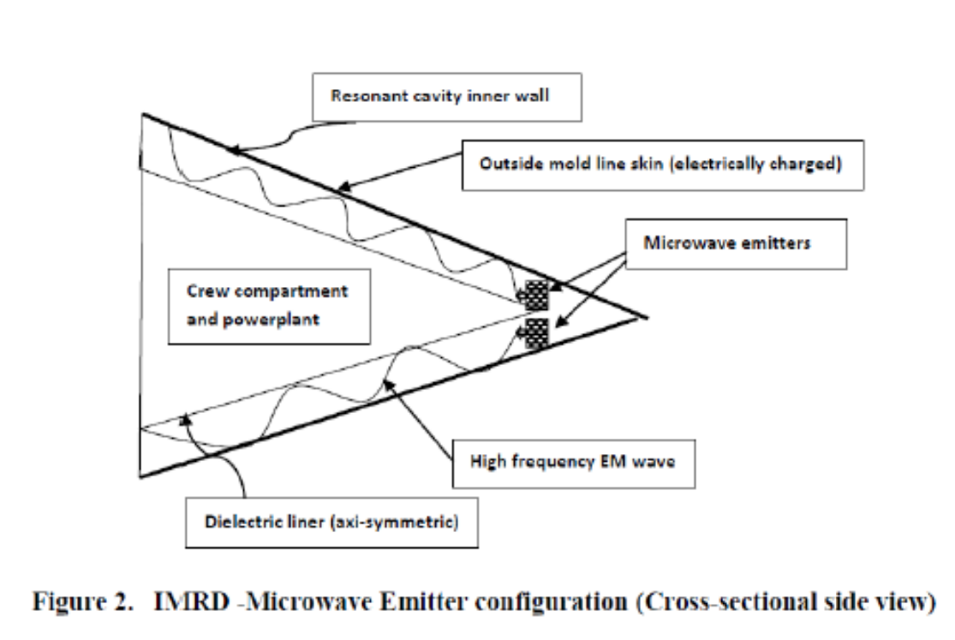
The coupling of high spin frequency with high vibration frequency in order to achieve the desired inertial (gravitational) mass reduction effect, can lead to the design of an Inertial Mass Reduction Device (IMRD), shown in figure 1 in a hybrid aerospace/underwater craft (HAUC) configuration. This device utilizes microwave-induced vibration within a resonant annular cavity. The manner and effectiveness with which the microwave energy couples with the resonant cavity inner wall is called the cavity Q-factor. This parameter can be written as the (Energy stored / Energy lost) ratio and is in the range of 104 to 109 (and beyond), depending on whether ordinary metal (Aluminum or Copper at room temperature) or cryogenically cooled superconducting material (Yttrium Barium Copper Oxide or Niobium Germanium) is used for the resonant cavity inner wall and outside mold line skin of the aerospace vehicle. One must realize that the high energy/high frequency electromagnetic field generator responsible for the inertial mass diminution effect would generate a repulsive EM energy field while in earth’s atmosphere, thereby repelling air molecules in its path of ascent/flight. Consequently, once in orbital space, by local Vacuum polarization (quantum field fluctuations’ modification), a repulsive gravity effect (recall the negative pressure of the polarized Vacuum condition) would permit swift movement of the hybrid craft (which comes in either a cone or lenticular triangle /delta wing configurations), beyond our Solar System. A plurality of microwave antennas (high radio frequency emitter sources) in the electromagnetic (EM) spectrum range of 300 Megahertz to 300 Gigahertz are arranged within the annular duct - resonant cavity (surrounding the crew compartment and powerplant system, which would be guarded in a Faraday-type cage, against all EM radiation effects), as portrayed in figure 2. An auxiliary propulsion unit (not shown), would provide the initial aerospace/undersea hybrid vehicle thrust and electrical power generation. Furthermore, if the annular resonant cavity duct is filled with a noble gas such as Xenon (inert), the microwave energy collision with the gas particles will induce a plasma state of matter (further augmenting the oscillatory vibrations experienced by the resonant cavity inner wall), thereby creating a highly nonlinear environment (phase transitions / abrupt changes of state from gas to plasma, which induce symmetry breaking) which will intensify the Prigogine effect (order from chaos - reference 4). This will enable the coherence of quantum vacuum fluctuations in the proximity of the outside mold line skin (electrically charged) of the aerospace vehicle, in this manner assuring a high degree of vacuum polarization. Therefore, it is possible to envision a hybrid aerospace / undersea craft (HAUC), which due to the physical mechanisms enabled with the IMRD, can function as a submersible craft capable of extreme underwater speeds (lack of water-skin friction) and enhanced stealth capabilities (non-linear scattering of RF and sonar signals). This hybrid craft would move with great ease through the air/space/water mediums, by being enclosed in a Vacuum plasma bubble/sheath, due to the coupled effects of EM field-induced air/water particles repulsion and Vacuum energy polarization.

-------------------

Pais, S., "High Frequency Gravitational Waves - Induced Propulsion," SAE Technical Paper 2017-01-2040, 2017, doi:10.4271/2017-01-2040.

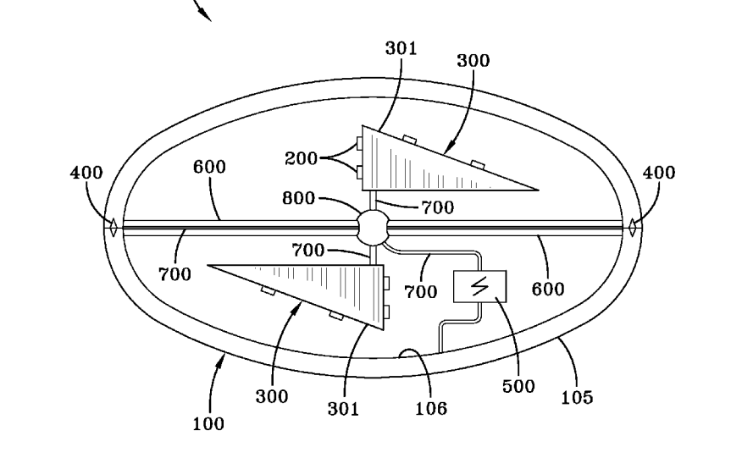

Utilizes the Gertsenshtein effect, that is gravittional wave production by propagating electromagnetic radiation trhough storng magnetic fields. Hfgw in turn generate their own gravitational fields upon wich the craft would propogate in a 'wave surfing' fashion.

The JASON report considers relatively low EM energy fluxes, when compared with those generated by the physical mechanisms described in reference 9 (on the order of 1033 W/m2 , and beyond). This exceptionally high EM power intensity induces spontaneous particle pair production (avalanche), thereby ensuring complete polarization of the local Vacuum energy state, thus resulting in modification of the local spacetime energy density. It is this possibility which may alter the aforementioned report’s conclusions. [also see Li-Baker Effect and possible power boost to Gertsenshtein effect.]

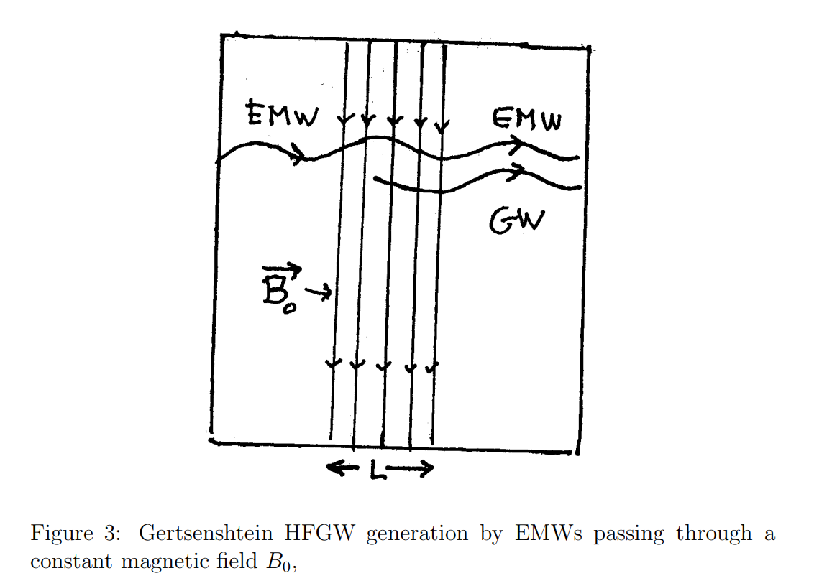

Referring to the JASON report [10] we note that enabling the Gertsenshtein effect will result in the generation of a gravitational wave (out) by passing an electromagnetic wave (in) through a strong static magnetic field (these waves are of equal frequency). By combining equations 3-13 and 3-14 on page 10 of the report we obtain equation 5:

where G is the universal gravitational constant, c is the speed of light in free space, B0 is the magnetic flux density of the static magnetic field operating over a distance L, and P_{GW}(out) is the gravitational wave power achieved from an electromagnetic wave of power P_{EM}(in).

It is important to note that a simple dimensional analysis shows that there is a factor missing in equation 5 (as written in the JASON Report) equal to the inverse of the magnetic permeability of free space, namely a factor on the order of 10⁶ .

Omitting this fact however, we can still show that by using a high frequency / high energy electromagnetic field generator we can produce HFGW exhibiting power levels on the order of 10¹⁰ watts, for an input EM energy flux on the order of 10³³ W/m2 , where B₀ is the magnetic flux density, on the order of 10¹⁰ Tesla which is also produced with accelerated motion of charged matter under rapid acceleration transients.

Furthermore, by using equation 3-25 in reference 10,

we can show that such HFGW power levels are equivalent to 1035 gravitons/sec production rates. These extremely high graviton production rates further show that if multiple high power, high frequency gravitational waves were to be focused on a particular point in a spacetime locality, they can induce a spacetime curvature singularity, namely a “highly distorted and disrupted patch of spacetime fabric” [11, cites G. Fontana here].

The electrified skin of the craft can be further vibrated in an accelerated manner using imbedded lead zirconate titanate (PZT) modules (details not shown in figure 1 due to possible security classification) which would generate the strong magnetic fields necessary for the enablement of the Gertsenshtein effect (nested EM fields). If the HAUC craft has a modular electrified outer skin design, composed of an ensemble/collective of miniaturized electrically charged surfaces, independently or collectively vibrated, then the craft can be very large in size.

------------------------------------------------------------------------
Space, Propulsion and Energy Sciences International Forum (SPESIF), 24-27 February, 2009, Edited by Glen Robertson. The Standard Quantum Limit for the Li-Baker HFGW Detector Gary V. Stephensona

But in contrast, the SQL does not appear to affect the operation of the Li-Baker detector design at the currently specified sensitivities. Comparing the Li-Baker Detector SQL to Gertsenshtein Detector SQL, we find that SQL_{LB} = h_{det} = 1.8(10)^{-37[}, [Li-Baker] ] versus SQL_{G} = h_{det} = 6.7(10)^{-22[} [Gertsenshtein ]Thus there is a 16 order of magnitude difference calculated between the two detector types. Why is there such a significant difference between the two designs? Improvements in the Li Baker detector over the Gertsenshtein detector design may be accounted for by: first, improvements from fractal membrane use, accounting for a factor of ~10⁻¹⁰ in sensitivity, second, improvements from geometric “antenna gain,” accounting for a factor of ~10^{-2,} and finally a larger detector energy content, providing another ~10⁻⁴. So we see that while energy content of the detection system is important, most of the improvements are derived from quality factor differences.

Eugene Podkletnov

In a BBC news item, it was alleged that researchers at Boeing were funding a project called GRASP (Gravity Research for Advanced Space Propulsion) which would attempt to construct a gravity shielding device based on rotating superconductors,[8] but a subsequent Popular Mechanics news item stated that Boeing had denied funding GRASP with company money, although Boeing acknowledged that it could not comment on "black projects".[9] It is alleged that the GRASP proposal was presented to Boeing and Boeing chose not to fund it.[10]
In July 2002, an article by Nick Cook in Jane's Defence Weekly reported about Boeing's internal project GRASP — Gravity Research for Advanced Space Propulsion to evaluate the validity of Podkletnov's claims. The briefing obtained by Jane's says "If gravity modification is real, it will alter the entire aerospace business." The briefing allegedly says that Boeing, as well as BAE Systems and Lockheed Martin tried to approach Podkletnov directly and that "Podkletnov is strongly anti-military and will only provide assistance if the research is carried out in the ‘white world’ of open development."[11]
https://en.wikipedia.org/wiki/Eugene_Podkletnov

Russian research of Shkatov may of be interest, but need article translated, 'experiments with the poynting vector'.

Неэлектромагнитное силовое взаимодействие при вращении масс в вакууме В.Н. Самохвалов1

Non-electromagnetic power
rotation interaction
masses in vacuum
V.N. Samokhvalov1
Abstract—The results of experimental studies of the interaction of rotating disks made of non-ferromagnetic materials are presented.
having a variable quadrupole moment, and their
force action on moving masses in a medium vacuum - the occurrence of rotation and repulsion of solid bodies from a rotating mass. The experimentally established value of the mass-dynamic repulsive force acting on the screen,
from the side of a rotating (160 1/s) disk with a mass of 50
g, was about 2.5 ... 2.7 N, and the magnitude of the mass-dynamic torque was about 1 N cm.
This is more than 20 orders of magnitude greater than
gravimagnetic forces determined by general relativity. The experimentally established force effects give
reason to believe that in nature a significant
role is played by the type of interaction due to
relative movement of masses, such as
what happens in relative motion
electric charges.

Etkin paper Heim's meso field is torsion field:
About interaction rotating masses
V.A. Etkin
Abstract—It is shown that the uneven distribution of the angular momentum in space generates an interaction that cannot be reduced to its four known types [em, weak, strong, gravity]. An explanation is given for a number of manifestations of this interaction from the standpoint of energy dynamics.

VII. The discussion of the results
Based on the energy dynamic principle
distinguishability of processes by special, qualitatively different and not reducible to other changes in state, to
which they cite, we are forced to admit the existence in media with inhomogeneous vorticity
in addition to the 4 known types of interaction (strong,
weak, electromagnetic and gravitational) more
one - torsion (rotational) interaction,
causing the transfer of vorticity, the repulsion or attraction of rotating masses (the emergence of gyroscopic thrust), and the ordering of the orientation of the axes of their rotation (reorientation). A sufficient basis for such a conclusion is that
the circumstance that no known interaction has produced such state changes
interacting bodies. In particular, gravity
the interaction of bodies removed at a certain distance depends solely on their masses and has
always the same sign (i.e. does not have chirality). Electrostatic interaction of remote
charges does not cause the rotation of charged bodies, although
changes attraction to repulsion depending on
charge sign. There is no magnetic interaction
in rotating non-magnetic bodies and is not indifferent to
their structure. Strong and weak fields do not have
long-range interaction inherent in the interaction of rotating bodies, as well as chirality and aftereffect
(presence of residual state changes).
All three processes described above are generated by a single cause - non-uniform distribution of the momentum of rotational motion in space. So
they are manifestations of the same species
rotational interaction. This testifies to
the existence of another field in space, which, following [22], we will call the torsion field
(a term introduced by E. Cartan in 1922). However
this does not mean understanding the torsion field as some material entity that carries out the transfer of rotational motion and tangential acceleration of the bodies located in it. On the contrary, contrary to the existing understanding of the field as a kind of matter (along with matter), the definition given here
torsion field comes from the understanding of the field as a region of space in which any forces or their moments are found, i.e. from its abstract mathematical definition as a set of any quantities at various points in space into one
and the same point in time. This definition is always true, whether it is a vector or scalar field, electric or gravitational, temperature or
concentration. Like any mathematical object, fields are non-material and cannot exist without
"field-forming" material environment, uneven
filling all space. On a macroscopic
level of description, this environment can be divided on the basis of the structural hierarchy into discrete (substance) and
continual (ether or physical vacuum as its
unsuccessful quantum analogue).
Force fields (gravitational and electric, magnetic and torsion) with a characteristic of each of them
type of interaction are generated by an inhomogeneous distribution in the space of properties of this real
environment - its masses, charges, currents and moments of impulse.
In this case, it would be erroneous to attribute to the ether
or physical vacuum the same properties as the substance formed from them, since the carrier
energy can be different structural forms of matter. In this respect, energy can be likened to
traveler changing means of transportation.
This happens when the exchange of energy between aether and
substance is carried out not by transferring an energy carrier (i.e., while maintaining its form), but as a result
transformation of energy from one form to another
energy carrier). In this case, the transfer of energy to
space is carried out in a different form than
in substance. This approach brings energy dynamics closer
with quantum field theory, in which energy transfer is explained by the emission and absorption of bosons
(particles - carriers of interaction).
Another conclusion concerns the concept of gyroscopic force introduced in 1879 by W. Thomson and P. Tet.
They defined it as a speed dependent force,
but doing no work on any real
moving the system. They referred to these forces
gyroscopic force, as well as the Coriolis force and
Lorentz, which are directed along the normal to the velocity
movement. However, forces, according to the laws of conservation
momentum and its momentum, appear only in pairs,
which, being directed not along one straight line,
create moments of forces, which is reflected by the members of the third sum of the basic identity of energy dynamics (1).
It is these moments, and not the forces mentioned above
perform the work of reorienting the axes of rotation of gyroscopes, fluid flows and electric charge.
Therefore, it is more correct to speak about the moments of gyroscopic, Coriolis and Lorentz forces than about them.
themselves.
Another conclusion concerns the expediency of creating a unified field theory and the “grand unification”
all interactions. The existence of another kind of interaction underlines the far-fetchedness of this
ideas and brings to the fore the task of development of a unified method for finding clearly distinguishable
forces and their moments responsible for various types of
interactions.

-------------------------

Steve Greer

on the fake war threat created by secret technology of the MilInd Complex:

some years ago I had a meeting with the crown prince of Liechtenstein Hans Otto
von Lichtenstein he had reached out to me through some of his contacts he said look doctor here we have to meet but we can't talk about this on the phone your efforts to effect disclosure are noble but they will not be able to be permitted and not for the reasons you think I saw well this is interesting finally we got together in New York City in July of 1994 he said to me in 1989 a group of us were trying to do disclosure and it involved Gorbachev President Bush senior himself and the UN Secretary General Perez de Cuellar and in the course of us putting together and the high-level planning meetings to do this Paris de cuéllar the UN secretary-general was abducted out of his limousine in Manhattan he was told by the aliens that if they did not cease and desist from their plans to just disclose this information that every
world leader involved including the President of the United States would be
abducted this blew up like they an atomic bomb in the Bush White House and it did not go forward I said okay well tell me more he says well we've concluded that we have to prepare the public for an interplanetary war and in doing so we can then also force the return of Christ and I'm quoting and I just listened he didn't know that I knew that the means for that abduction
prepares to play are were run by a counterintelligence unit out of the national security state that had the technologies to simulate an alien craft and aliens run completely by military
assets and that there was a deeper part of these unacknowledged special access projects that were zooming even people like Bush Senior who was on the committee but had lost control of some of these renegade factions Perez de Cuéllar being abducted caused him to
stop that process it manipulated these leaders into going on to a war footing and he confessed to me that the reason he was funding the of the abduction groups was because they wanted to put information out to the public that would scare the public so the people would make the sacrifice and blood and treasure to have aninterplanetary war

Document on Psyops and UFOs from Greer collection:

documents were released 40 years after alleged production in the 1950s.
see https://www.youtube.com/watch?v=CfIetGulZhE&t=27s

Expose of the National Security State Jan 25, 2016
Timestamp: 20:46 of video

...1953 although you can't see the date on it very well here and it's about the the it's written by
the director of the CIA to the director of psychological strategy board psychological strategy board what psychological warfare and it says you can read it I'm transmitting to the National Security Council a proposal tab be a which we don't have which is concluded that the problems connected to UFOs appear to have implications for psychological warfare as well as for intelligence and operations and then there's another tab B which has the background I'd love to see that one I suggest that we discussed in an early board meeting the possible offensive or defensive utilization of these phenomena for psychological warfare purposes
remember this document four hours from now because basically what they
concluded was they needed to do a few things they wanted to be able to set up a deception around the subject and put out false information use it as a cover story for classified aerospace research so oftentimes there will be something that happens and it will look like a UFO and it's actually a Northrop Grumman, my uncle's company was Northrop Grumman he worked on the thing that landed on the moon the lunar module, or Lockheed Martin Skunkworks or some other aerospace entity and it will be a hundred percent man-made and the public will say, “oh my god it is a UFO” and they'll not be correct

Giorgio Fontana

Why we live in the Computational Universe Giorgio Fontana (2005)
Assuming that the Computational Universe is made as an image of the First Level Universe, then the Computational Universe appears as an extended body in the space-time of the FLU. Taking into account that in a computer simulation, simulation quantities are unrelated to the “mother computer”, hardware related, quantities that describe its state of motion in the FLU, the external quantities take their values in external dimensions. The external state of motion therefore adds seven additional parameters, three translations, three angles plus an additional absolute time. The seven parameters add six hidden space-like dimensions to the dimensionality of each particle of the Computational Universe and the additional absolute time parametrizes the evolution of the entire four-space. Summarizing, in the Computational Universe there are four large dimensions, six hidden dimensions and an absolute time.

Paper: The Four Space-times Model of Reality (2004):

baryon matter is 1/5th total mass of the whole matter universe, antimatter could be confined in 4 or 5 parallel universes or spatial dimensions this resolves the dark matter issue each with almost the same total mass this resolves the dark matter issue, each with almost the same total mass. Time is a secondary role not a dimension, it is a derived coordinate.

4 Fundamental Large Spatial Dimensions (4 Space) they are four 3+1 spacetimes.

Euclidean Special Relativity (++++)
our 3+1 space-time is described embedded in 4 Space.
In Special Relativity (dt)² = c²(dt)² – (dx)² – (dy)² – (dz)²
coordinates t,x,y,z where τ (proper time) measure of the distance
In ESR c²(dt)² = (dτ)² + (dx)² + (dy)² + (dz)²
τ,x,y,z coordinates of the Four Space, t paameter used to evaluate velocity and acceleration, the equation is the definition of time, t is a local function of changes. Time exissts if there is motion in the 4 Space.

Symmetry: Lorentz transformation SO(4)

photons cannot move along the space dimension τ, the matter universe runs along τ with speed c, our space-time consists of a continuum of τ-frames. Particle P can reach another spacetime P->P' with a Lorentz transformation, a SO(4) rotation, travelling between differrent τ-frames requires a change of the local speed of light, this in turn requires a refractive index diffferent from unity (1) for the propogation of massive particles and the effect is produced by the presene of a gravitational field.

The 4 Space encodes past, present, future in its four dimensions, past and future τ-frames is only a process.

4DO, theory of gravity in Four Space. It is possible to convert the metrics of GR into refractive indices (Almeida 2004b). 4DO is non-linear like GR and therefore capable of offering many interesting developments gravity propogates in 4D, photons trave in 3D and a propogation loop between 2 photons at different τ in 4D is not posssible, EM is linear.

ESR and the otion of a refractive index of the 4 space are significant departures from the concepts of GR; 4 Space is flat, it has a refractive index, everything that is not a refractive index is in motions and the v is a function of refractive index like gravity. Forces are associated to changes in the trajectory of particles due to the refractive index, F is a projection of trajectores in the 4 space. The refractive index of the 4 space could be a function of fr3equency. Frequency modulation of a particle wave function (by vibrations at relativistic speeds in the 3 space) should change its frequency specrum and control the intensity of thenatural force.
Experiments similar to HFGW are suggested tos tudy the properties of the refractive index of the 4 space.
….identify the refractive index with a memory device in which wave/particles play the role of signals flowing trough the 4D optical circuits of the universe (similar to Zuse cellular automata, calculating space, 1969)
“the cpacity of traveling can be defined as the cpacity of steering in 4 Space that is the capacity of making Lorientz transformations. Gravity assist is not propulsion, it is steering, HFGW can be used for gravity assist.

Space travel betweeen different τ-frames possible by locally changing the refractive index and the effect is produced by the presence of a gravitational field.

CONCLUSION
The properties of the graviton in space-times with a cosmological constant and variants of SR strongly suggest that our 3+1 space-time is a special case in a more fundamental 4-space. The 4-space can host four electromagnetically orthogonal space-times, one of them is our space-time, in which we can only physically operate on a single frame along τ, that is the “present”. Gravitational phenomena can allow navigation in the 4-space and, as soon as technology will permit, it will be possible to discover the possible real existence and nature of the remaining three space-times. Observed gravitational phenomena have already shown that the total mass of the universe is four to five times the mass of the visible universe. This observation is encouraging for the presented approach. In addition, recalling the introduction, some parallel universes might be “antimatter universes”, therefore they can become a precious source of fuel for spacecrafts equipped with devices or engines capable of producing gravitational fields strong enough to capture even a limited flow of atoms in the parallel universe.

In Euclidean 4-space, extended with the Schwarzschild’s solution that suggests the existence of a refractive index, particles can travel with a speed higher than the speed of light without producing paradoxes. Within the simplest model, the most disconcerting property of the 4-space approach is that the perceived “flow of time” is obviously a “readout/modify” process of a predetermined or prerecorded story encoded in the refractive index. The presented “almost static but reactive” view (which leaves the already visited regions of 4-space affected by the process) of the universe differs from the early interpretation of cosmology in GR, which was static and with no “events” or “choices”.

Abandoning “time t” as a principal dimension in favor of four spatial dimensions suggests the interpretation of reality as a “trip” in a prerecorded sequence of possibilities in which material objects follow the laws of physics and sentient beings can act by choosing their paths. It is implicit that the prerecorded sequence can be modified every time a “readout” is performed. Subsequently this happens in the “present”, but it may happen in the “future” and in the “past” along the τ space coordinate respect to our space-time. Like General Relativity, the presented Euclidean model of reality admits something like time travel. It is not time travel indeed; it is τ travel. Personal (local) time t cannot be affected because it depends on Lorentz invariance, a τ traveler can jump into different time-lines (sequences of τ frames) and follows them actively as soon as the τ travel machine is switched off. In the 4-space this is indeed space travel.

It's not time (t) travel, it proper time (τ) travel according to Fontana.

====================
Paper- Design of a Quantum Source of High Frequency Gravitational Waves and Test Methodology (2004)

collision or focusing of gravitational waves produce curvature singularities, which have properties similar to black holes. Generatos of Gws could be installed directly onboard or remotley to a spacecraft to induce curvature singularities near the spacecraft. According to GR spacecraft mass interacts with spacetime curvature, therefore the spacecraft will move towards the singularity.

The produced Gws must have a wavelength of at least mm length (microwaves), because it is necessary to collimate or focus the waves to, a small spot to reach the high energy densities that produce non-lenearity effects colminating with the creation of apaacetime singularities

Only at the quantum there is a precise distinction between gravitational and em transitions. Gws produced with a GASER, see Chiao 2017 paper.

-----------
Paper: Gravitational Wave Propulsion (2005)

gravitational wave generators with high power and short (mm) wavelenghts for producing high energy densities.
The study and development of gravitational wave propoulsion is a very challenging endeavor, involving the most complex theories, sophisticated materials and the testing techniques ever conceived by science. The development of of Gravitational wave propulsion appears to be within reach of a larrge national or worldwide research program.

Describes the gravittattional field as a distortion of the geometry of space-time as a function of energy, momentum densities and stresses in a source:

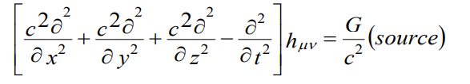

They do not use linear GW but non-linear GW. The differeence between GW and EM waves emerges if the non-linear nature of GW is considered.

Novello and Neves (2003) graviton has a mass in an anti-de Sitter background given mby m2g = -2/3Λ
a reaction mass can be producedd for propulstion applications.

Christolou memory effect:
“The nonlinearity effect is better exploited if the gravitons are slowed down in order to increase their density. This indeed happens outside the Schwarzschild radius of singularities created by focused beams of GW. In fact, another property of gravitational radiation that may find application to space travel is the so-called collision problem. The interaction of two impulsive plane waves with infinite wavefronts starts a self focusing process which is believed to end with the creation of a space-time singularity regardless of the amplitude of the wave (Szekeres, 1992).” pg. 1334

The collision of gravitational waves produces a coulomb like gravitation field if created outside a spacecraft, the spaceccraft would free fall toward the gravitational distortion. Navigation techniques are indeed those designed for gravity assist, with the natural gravity source replaced by a nearer artificial gravity source.

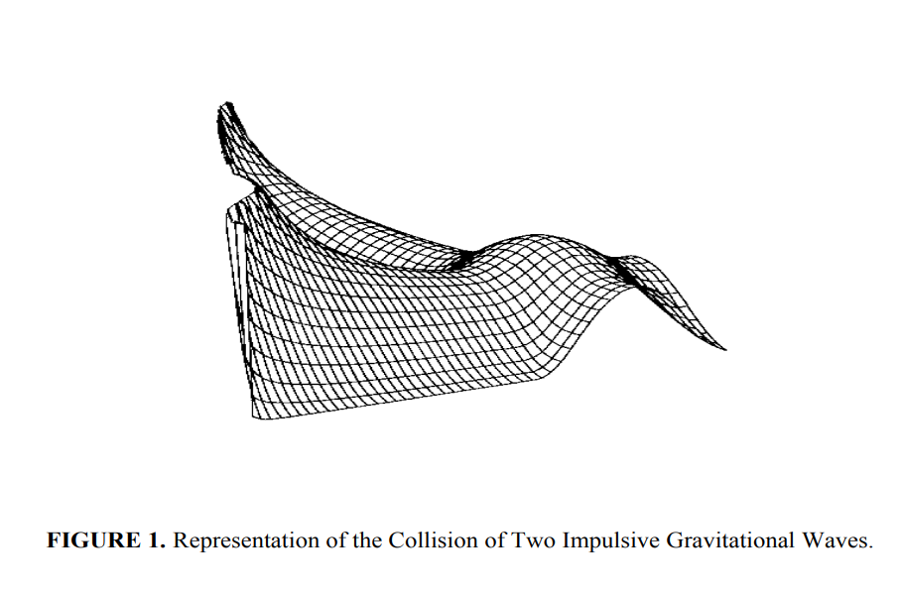

The result is equally valid with the more realistic beam-like gravitational waves (Ferrari, 1988c), and the interaction of two graviton beams (Veneziano, 1987). The collision of gravitational plane waves may produce a curvature singularity or a coordinate singularity, and the radiation is completely converted in a coulomb-like gravitational field (Ferrari 1988b). pg. 1336

Many relativists believe that Gws are pure transverse waves and therefore unsuitable to induce permanent displacements...This is not correct. We have numerous examples of rigorous derivation of non-linear effects in G that supports the opposite. pg. 1336

----------

Paper Hyperspace for Space Travel (2007)

Tavelers and local universes meet and interact when both trajectories are aligned and the refractive index n of the Hyperspace is uniform, therefore permitting quantum computable photon exchange.

Practically, the main problem that the Hyperspace traveler must understand is how to comeback to the originating space-time after a trip in the Hyperspace, and how to travel and get there faster than light in some giben intermediate space-time.

It has been shown that the propogation of all particles in the Hyperspace can be described similarly to lihgt propogation in a space-time with the refractive index of the Hyperspace entitled to control the propogation speed.

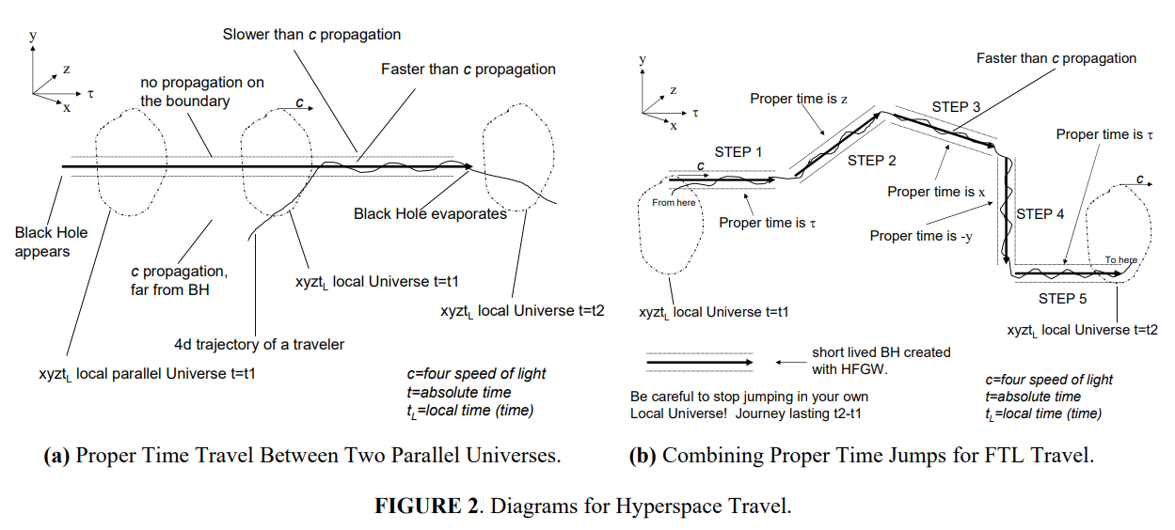
“the action in Fig 2(a) does indeed represent a proper time machine; the traveler is detached from it's own space-time [3+1] and ends the trip in a different proper time frame. Conventionally, the requirements are that of a horizon and a Schwarzchild-like metric, with or without a singularity, the exact expression looks unimportant, and we can anticipate that other metrics can offer a viable solution” Pg. 1121

Black Hole in the Hyperspace: the conventional BH is clearly a good candidate for a form of FTL travel... if we approach the horizon lines from outside, thenn the propogation speed goes to zero and then it rises to FTL, by going inside the tube.

...the Hyperspace is now enforced by the notion that reality is memorized in the refractive index of the Hyperspace... the Hyperspace is therfore characterized by an absolute system of coordinates which univocally locate the information (x,y,z,t).

maneuvering in and out of the horizons of BHs can be naturally achieved by finding binary Bhs, differently from Fig. 2, the horizons have now sine patterns, and the traveler trajectory can enter and escape the horizon because the horizons move, the effect on the traveler is the same, change of the speed along the proper time coordinate, thereforew we have space travel.

Superliminal tunneling or Hyperspace teletransportation of an object.
“The fluctuation of the refractive index of the Hyperspace is of the same order of magnitude of the adimensional amplitude of the HFGW, therefore a properly tuned interference pattern of HFGW with quite low amplitude can bounce protons and neutrons in the Hyperspace. A “dynamically changing” interference pattern can pick-up and move objects made with protons and neutrons. This technique can be easily converted to propulsion if the generators of HFGW move, and the interference pattern captures nearby objects or the earth itself and push them away. It must me observed that Bragg reflection will act on the wavefunctions of elementary particles taken one by one, the collective wavefunctions might be treated differently, depending on their respective de Broglie’s wavelength, leading to never before observed effects.” pg. 1123

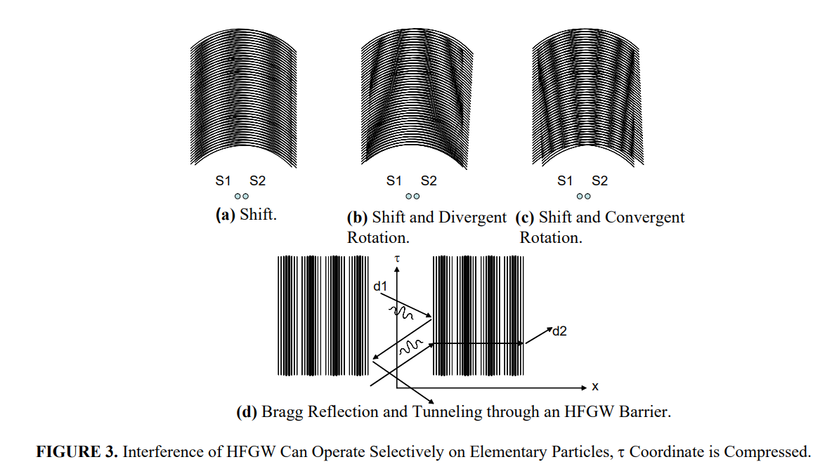

The collision, or focusing of HFGW is a non-linear process, on the other hand HFGW can produce a linear gravitational-like interaction. In fact material particles can be described by wave-packets or matter waves, traveling at the speed of light in the Hyperspace (Almeida, 2000). If it were possible to spatially-periodically modulate the refractive index of the Hyperspace, we could easily obtain effects like the Bragg refraction and reflection of conventional wave optics. To do so it is necessary to modulate the refractive index of the Hyperspace with wavelengths of the order of λ=h/mc, with h Planck’s constant, which is the Hyperspace de Broglie’s wavelength of the transported particle as defined by (Almeida, 2000). In the Hyperspace, a Gravitational wave is a propagating perturbation of the refractive index and therefore it might become the source of a new form of selective gravity. As a matter of fact, for a proton, the Hyperspace de Broglie’s wavelength is about 1.32⋅10-15 m and for an electron it is about 2.4⋅10-12 m, they are constant because all particles travel at the speed of light in ESR. HFGWs produced by the nuclear generators of HFGW (Fontana and Baker, 2006) which can operate at ω=3.03x1024 s-1 and wavelength of 6⋅10-16 m, can be adopted to practically implement those effects. Specifically a couple of synchronized generators, at a distance apart far larger than the HFGW wavelength (Baker, 2006), can be operated in an interaction mode that is to synthesize interference patterns which can create Hyperspace channels tuned to specific particles. For instance all the protons and neutrons of on object can be transported, while electrons are differently affected. Fig. 3 reports the different possibilities of HFGW interference patterns of two generators S1 and S2, by applying shift (a), shift and rotation divergent (b) and convergent (c). Hyperspace trajectories of particles are shown: d1 is transport, d2 is superluminal tunneling or Hyperspace teletransportation of an object. Particles may travel along a guided path, they may also tunnel through HFGW energy barriers. In the example d1 is running backward in the proper time of that universe, but its time t is running forward as required by the Mother Computation. Fiber Bragg grating theory and technology (Huang, 1999; Ouellette, 2001) are helpful to establish that with fluctuations in the refractive index of the order of 10-10, 99% reflection can be obtained with a 25 mm long Bragg grating tuned at the de Broglie’s wavelength of the proton. The fluctuation of the refractive index of the Hyperspace is of the same order of magnitude of the adimensional amplitude of the HFGW, therefore a properly tuned interference pattern of HFGW with quite low amplitude can bounce protons and neutrons in the Hyperspace. A “dynamically changing” interference pattern can pick-up and move objects made with protons and neutrons. This technique can be easily converted to propulsion if the generators of HFGW move, and the interference pattern captures nearby objects or the earth itself and push them away. It must me observed that Bragg reflection will act on the wavefunctions of elementary particles taken one by one, the collective wavefunctions might be treated differently, depending on their respective de Broglie’s wavelength, leading to never before observed effects. pg. 1122-3

Bibliography:

Häuser, J. & Dröscher, Walter. (2021). Gravity beyond Einstein? Part III: numbers and coupling constants, contradictory experiments, hypercomplex gravity like-fields, propellantless space propulsion. Zeitschrift für Naturforschung A. 10.1515/zna-2021-0147.

OFFICE OF THE DIRECTOR OF NATIONAL INTELLIGENCE (2021) Preliminary Assessment: Unidentified Aerial Phenomena, Department of Defense Unidentified Aerial Phenomena Task Force (UAPTF)
https://www.dni.gov/files/ODNI/documents/assessments/Prelimary-Assessment-UAP-20210625.pdf

US Congress, (2022) UNIDENTIFIED AERIAL PHENOMENA Tuesday, May 17, 2022 U.S. House of Representatives, Permanent Select Committee on Intelligence, Subcommittee on Counterterrorism, Counterintelligence, and Counterproliferation, Washington, D.C. https://docs.house.gov/meetings/IG/IG05/20220517/114761/HHRG-117-IG05-Transcript-20220517.pdf

